|  |
| --- |
| **TurnQuest Everest Insurance Suite**  **General Insurance System(GIS)**  **Underwriting User Manual** |



**01st September 2014**

**Contents**

1. NEW BUSINESS UNDERWRITING

1.1 Underwriting a New Direct/Intermediary Business Policy

1.2 Underwriting a Co-Insurance Business Policy

1.3 Underwriting a Facultative Inward Business

2. RISK VALUATION/SURVEY

3. ENDORSEMENTS

3.1 Revision of Cover

3.2 Extension of Cover

3.3 Policy Cancellation

3.4 Contra Transaction

3.5 Re-Use of Contra Transaction

3.6 Re-Use of Contra Transaction

3.7 Re-Use of Contra Transaction

4. POLICY RENEWAL

5. POLICY LAPSING

6. POLICY REINSTATEMENT

7. POLICY LOADING

8. POLICY ADMINISTRATION

9. REINSURANCE

# NEW BUSINESS UNDERWRITING

The various underwriting processes can be accessed from the underwriting menu list that is generated after clicking on the ‘Underwriting’ link on the home screen.

## Underwriting a New Direct/Intermediary Business Policy

* On the main menu panel, click **Underwriting**>>**New Transaction** on the main menu panel.

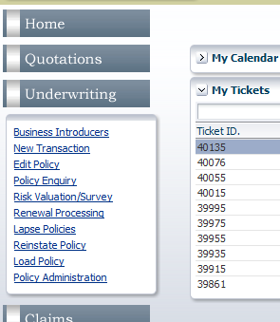

This brings up the ‘Underwriting Transaction’ screen

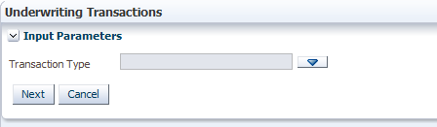

* Click  for the ‘Transaction Type’ field to bring up the dialog box with a list of transaction types.

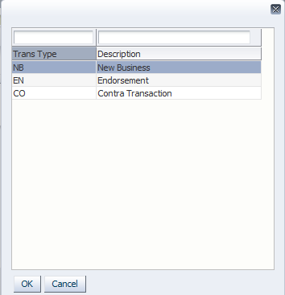

* Click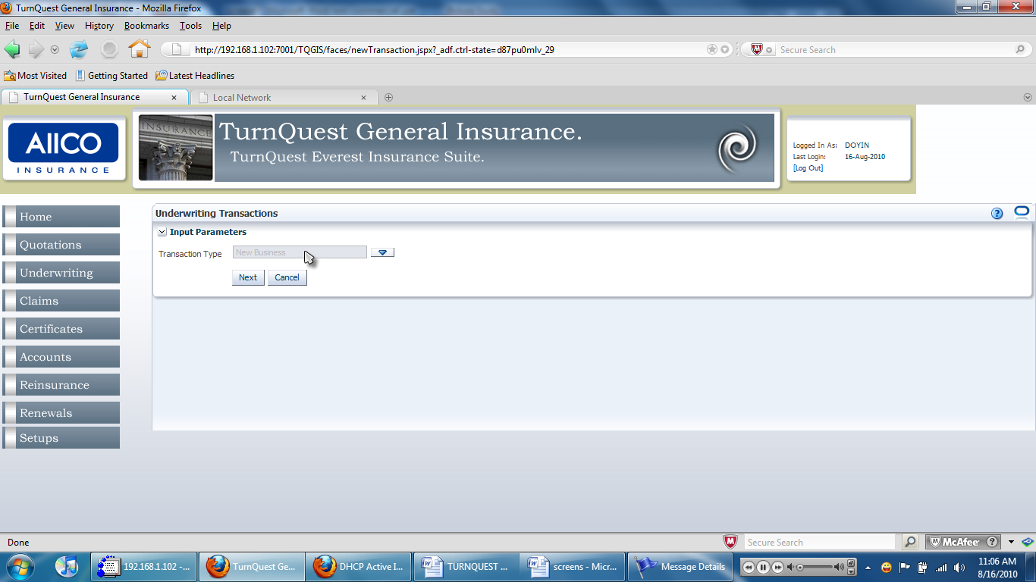 on the ‘Input Parameters’ pane to proceed. This brings up the ‘New Business Transaction’ dialog box.

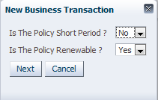

* Click 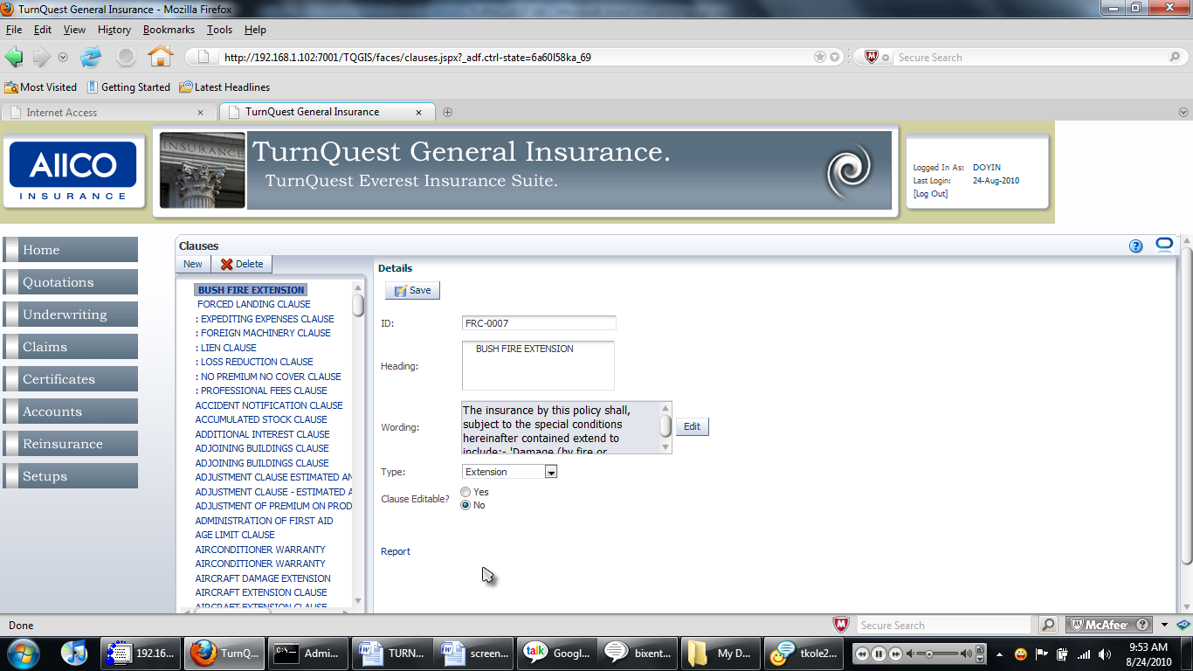 and select ‘Yes’ or ‘No’ to specify whether the policy is short-period and whether it is renewable.
* Click after making the selection. This brings up the ‘New Business Transaction’ pane with policy product details.

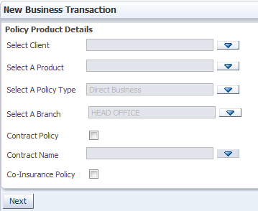

* The ‘Select Client’ field specifies the name of the client that is taking the policy. Click  to bring up the list of clients already set up in the CRM module.
* Click  for the ‘Select Client’ field to bring up the list of clients already set up in the CRM module.

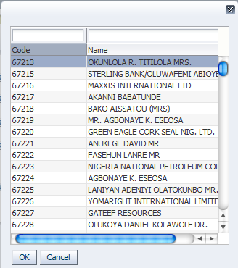

* Select a client and click 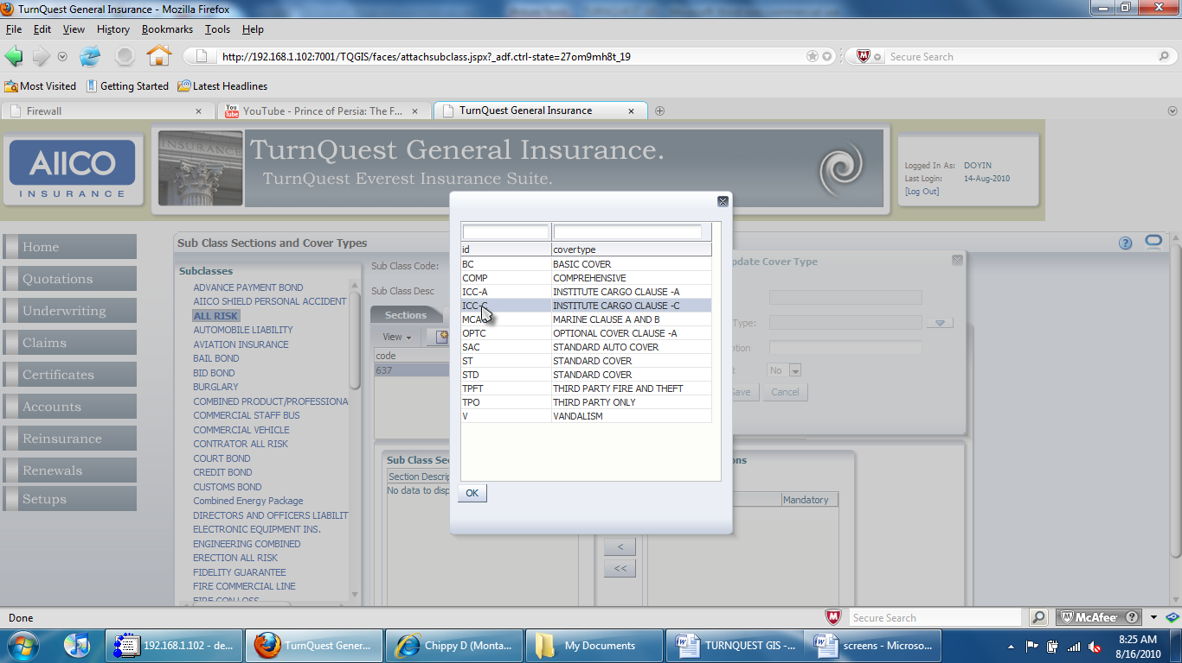 to populate the ‘Select Client’ field.
* The ‘Select A Product’ field specifies the product that the policy is being underwritten for. Click  to bring up the ‘Select A Product’ dialog box.
* Click  for the ‘Select A Product’ field to bring up the ‘Select A Product’ dialog box

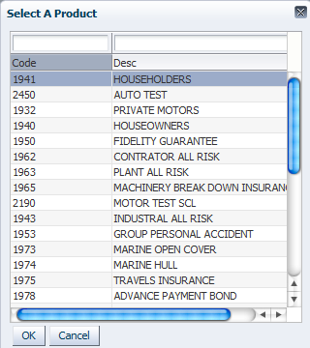

* Select a product and click  to populate the ‘Select A Product’ field.
* The ‘Select A Policy Type’ field specifies if the policy is direct business, intermediary or facultative inward.

: Selecting ‘Intermediary Business’ or ‘Facultative Inward’ introduces more fields in the policy product details.

* Click  for the ‘Select A Policy Type’ field to bring up the dialog box with a list of policy types.

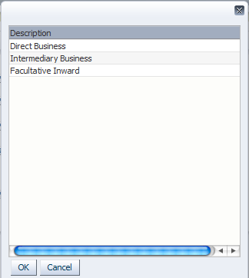

* Select a policy type and click  to populate the ‘Select A Policy Type’ field.

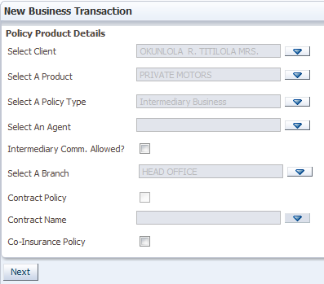

: Selecting ‘Intermediary Business’ for the ‘Select A Policy Type’ field generates the ‘Select An Agent’ field in the ‘Policy Product Details’ pane. The field specifies the agent who acts as an intermediary between the client and the company.

* The ‘Select A Branch’ field specifies the branch to which the logged-in user’s underwriting is to be attributed. It is populated with the user’s default branch (set up in CRM) by default.
* Click  for the ‘Select An Agent’ field to bring up the ‘Select Agent’ dialog box.

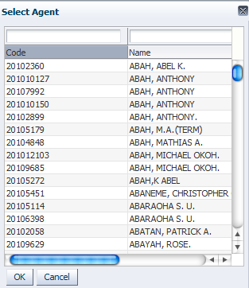

The list contains both agents and in-house agents. Commission rates must have been set up for these two account types (agents and in-house agents) under the subclass in use for the premium in this policy to be computed.

* Select an agent and click  to populate the ‘Select An Agent’ field.
* Click  after entering policy product details on the ‘Policy Product Details’ pane to proceed. This brings up the ‘Policy Details’ pane.

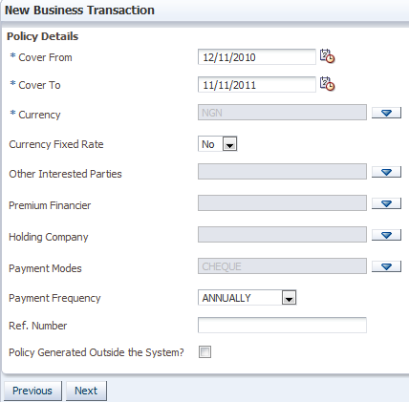

* The ‘Cover From and ‘Cover To’ dates specify the policy cover period.
* Click 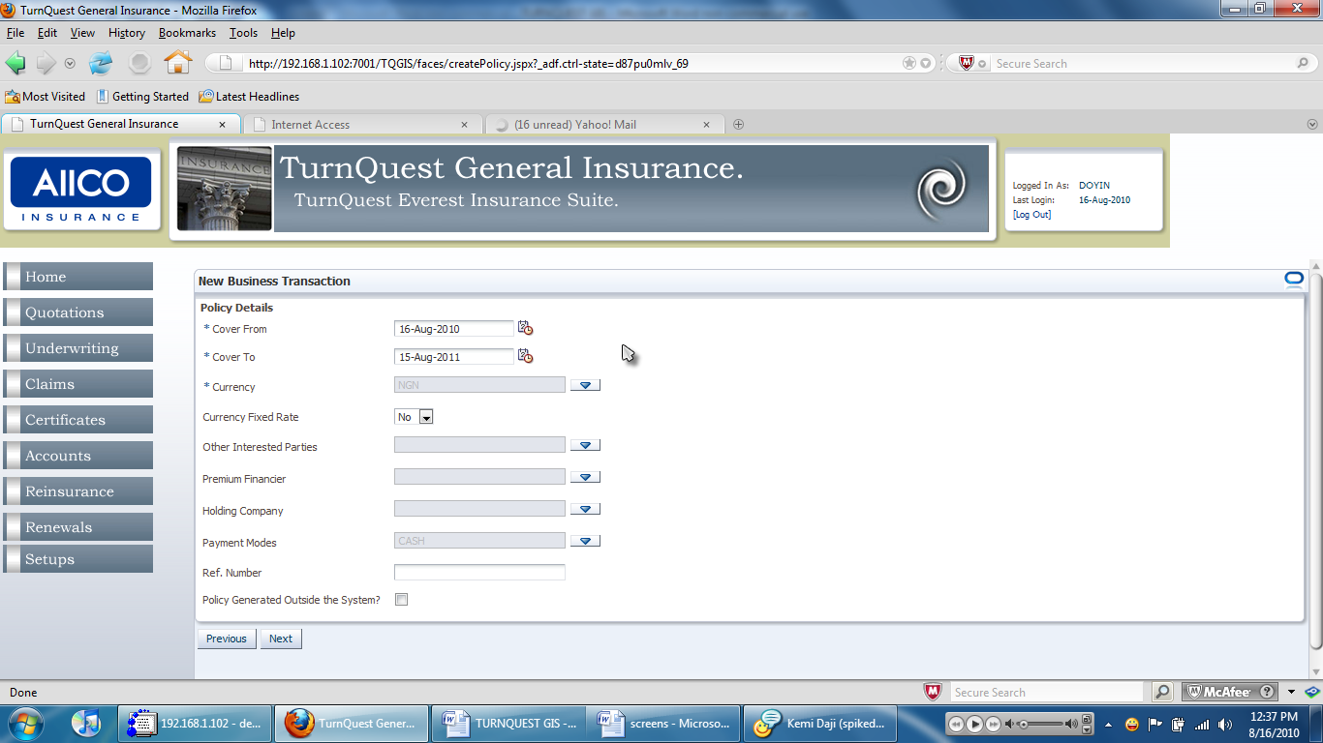 for the ‘Cover From’ and ‘Cover To’ fields to bring up the calendar.

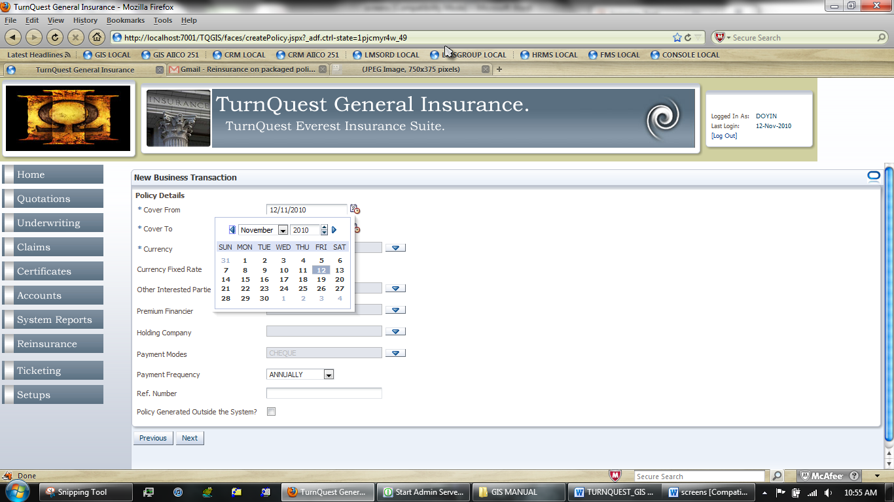

* Click  and select the desired month from the drop-down list, type in the year and click on the desired date to populate the ‘Cover From’ and ‘Cover To’ fields.

: These dates define just the policy cover. Separate dates are to be set to define the cover period of individual risks within the scope of the policy. The ‘Cover To’ date is automatically populated after selecting the ‘Cover From’ date but it can still be changed.

* The ‘Currency’ field specifies the currency in which the transactions are to be carried out and in which reports are stated.
* Click for the ‘Currency’ field to bring up the ‘Currency’ dialog box

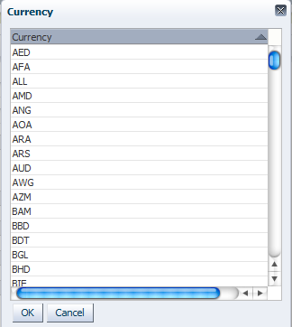

* Select the desired currency from the list and click  to populate the ‘Currency’ field with the selection.
* The ‘Currency Fixed Rate’ field indicates whether the policy will make use of a fixed rate for currency conversion. Selecting ‘Yes’ generates the exchange rate field.

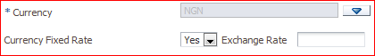

* Specify an exchange rate amount in the ‘Exchange Rate’ field.
* The ‘Payment Modes’ field indicates the mode of premium payment for the policy.
* Click  to bring up the ‘Payment Modes’ dialog box.

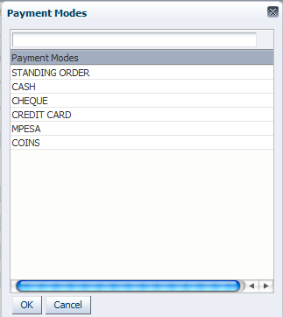

* The ‘Payment Frequency’ field indicates the frequency in which premium payments are to be made.
* Click  and select an option.
* The ‘Policy Generated Outside the System?’ field indicates that the policy was done outside the system. If the checkbox is checked, the ‘Policy Serial No.’ field is generated
* Click  to proceed. At this point, the system prompts the user about existing policies that the selected client already has.

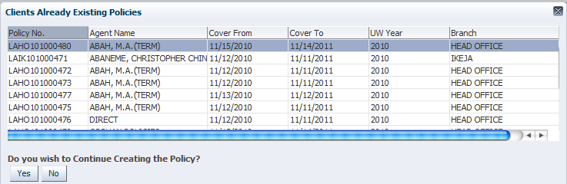

* Click to proceed to the ‘Risk Details’ pane

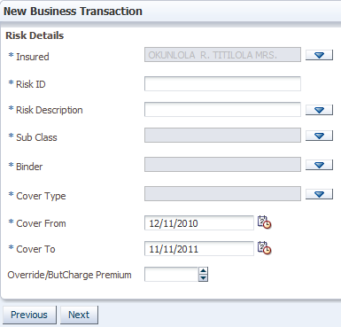

* The ‘Insured’ field indicates the party that is covered in the policy. This may not necessarily be the same as the client. The client could take the policy on behalf of the insured.
* Click for the ‘Insured’ field to bring up the ‘Select Insured’ dialog box

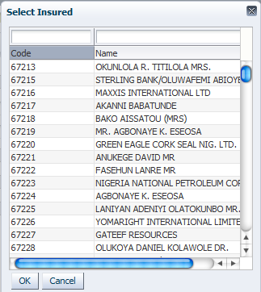

* Select an insured and click  to populate the ‘Insured’ field.
* The ‘Risk ID’ field is populated with a short identifier for the risk. This should be a unique ID for subclasses that have been set up to have risks with unique IDs
* The ‘Risk Description’ field is populated with a full description of the risk.
* The ‘Sub Class’ field is populated with the subclass that the risk to be covered belongs to. Click to bring up a dialog box with a list of subclasses attached to the selected product.
* Click for the ‘Sub Class’ field to bring up a dialog box with a list of subclasses attached to the selected product at setup.

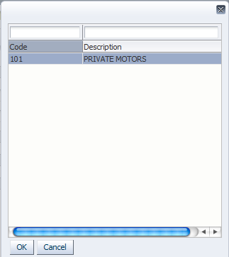

* Select the desired subclass and click  to populate the ‘Sub Class’ field
* The ’Binder’ field specifies the binder to be attached to the risk.
* The ‘Cover Type’ field captures the cover type to be attached to the risk.
* The ‘Cover From’ and ‘Cover To’ fields are automatically populated with the same dates as those earlier set for the policy.

: Each risk in the policy can have a different cover period from the policy as long as it is within that of the policy. The risk cover period is defined at this point.

* The ‘Override/ButCharge Premium’ field is used to override the premium calculated based on the sum insured
* Click  on the ‘Risk Details’ pane to proceed to the ‘Other Risks Details’ pane.

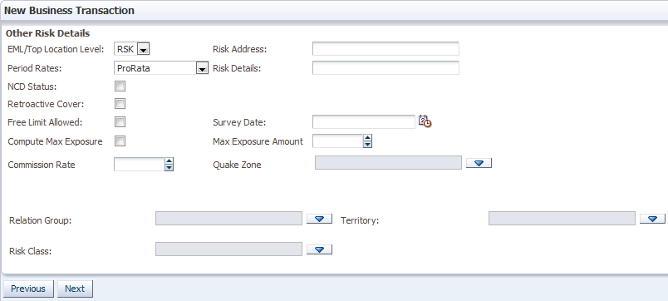

* The ‘Override/ButCharge Premium’ field is used to override the premium calculated based on the sum insured
* The ‘EML/Top Location Level’ field specifies whether the estimated maximum loss is computed at risk or section level. Click  and select ‘RSK’ for risk level or ‘SEC’ for section level.
* The ‘Period Rates’ field indicates the method by which the premium will be computed. Click  and select ‘ProRata’ for a prorated premium based on the number of days within the cover period. Select ‘Full’ for annual premium computation and ‘Short Period Rates’ for premium computation based on short period rates.
* The ‘NCD Status’ field indicates that no claim discount is applied for the risk if the checkbox is checked
* The ‘Retroactive Cover’ field is checked if the client wishes for the cover to start from a period earlier than underwriting
* The ‘Free Limit Allowed’ field indicates whether free limit is applied in premium computation
* The ‘Compute Max Exposure’ indicates whether maximum exposure will be computed
* The ‘Commission Rate’ field specifies the commission rate to be used in computing the commission for the intermediary. This overrides the rate specified at setup.
* Click  for the ‘EML/Top Location Level’ field and select ‘RSK’ for risk level or ‘SEC’ for section level.
* Click  and select ‘ProRata’ for a prorated premium based on the number of days within the cover period. Select ‘Full’ for annual premium computation and ‘Short Period Rates’ for premium computation based on short period rates.
* Click  to proceed to the ‘Risk Sections’ pane

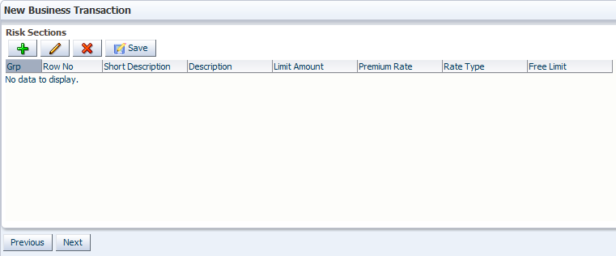

* Click  to bring up the ‘Applicable Risk Sections’ dialog box.

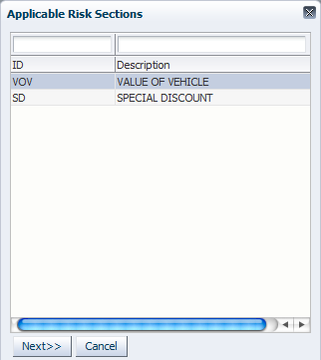

* Select a section and click  to bring up the ‘Risk Section Details’ dialog box.

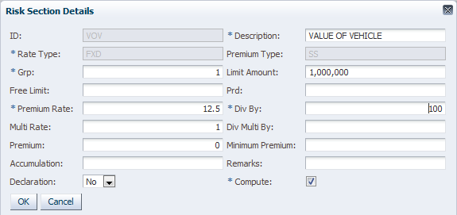

* The ‘ID’ field is auto-populated with the ID of the selected section
* The ‘Description’ field shows the description of the section which can be edited
* The ‘Rate Type’ field shows the rate type as it was defined when setting up the premium rate for the section
* The ‘Premium Type’ field shows the section type as defined at setup
* The ‘Grp’ (Group) field is used to put sections in various groups so that premium is computed separately per group and summed up later.
* The ‘Limit Amount’ field specifies the limit amount for the section. The rate is applied to this amount to compute premium.

: Limit amount should not be specified for loadings and discounts as these rates are applied to premium that has been computed from other sections.

* The ‘Free Limit’ field specifies the amount of the limit amount for which premium will not be calculated. The free limit functionality must have been enabled on the ‘Other Risks Details’ pane.
* The ‘Premium Rate’ field specifies the rate that has been set at setup. It can be changed at this point
* The ‘Div By’ field specifies the rate division factor. 100 means the rate is percent and 100 means it is per mille.
* The ‘Multi Rate’ and ‘Div Multi By’ fields are similar to the ‘Premium Rate’ and ‘Div By’ fields except that they are for a multiplier rate.
* The ‘Premium’ field is used to specify a premium amount if the rate and limit amount are not being used to compute premium.
* The ‘Minimum Premium’ field specifies the minimum premium allowed for that section.
* The ‘Remark’ field is used to add optional remarks to the section
* The ‘Declaration’ field indicates whether the section is a declaration. Click  and select ‘Yes or ‘No’
* The ‘Compute’ field indicates whether to compute premium on the section
* Click  to save the section details. The entry will appear on the ‘Risk Sections’ pane where figures can be edited.

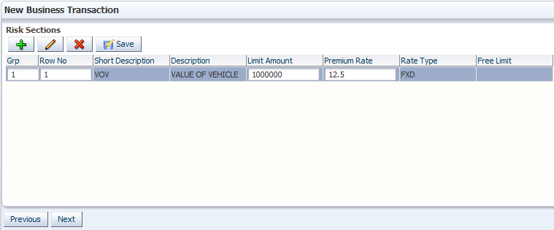

* Change figures as desired and click 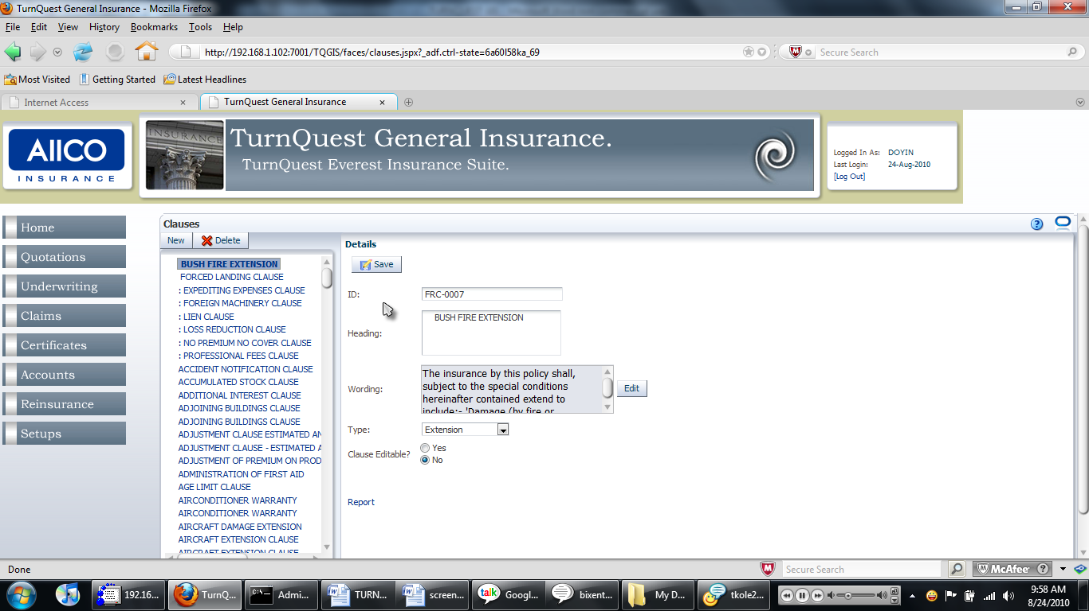 to save the new entries.
* Click 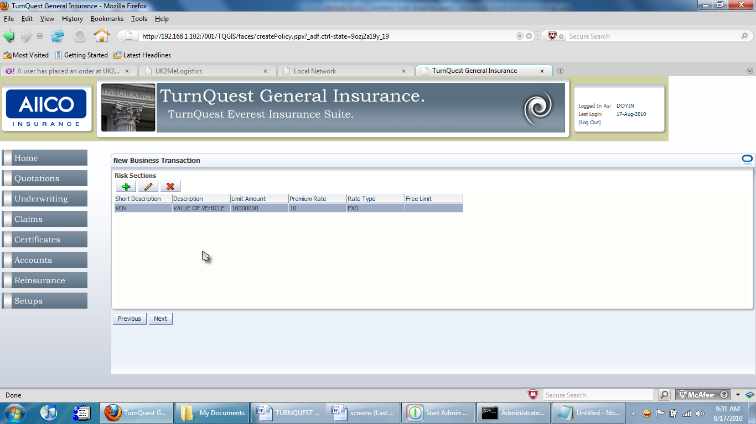 or 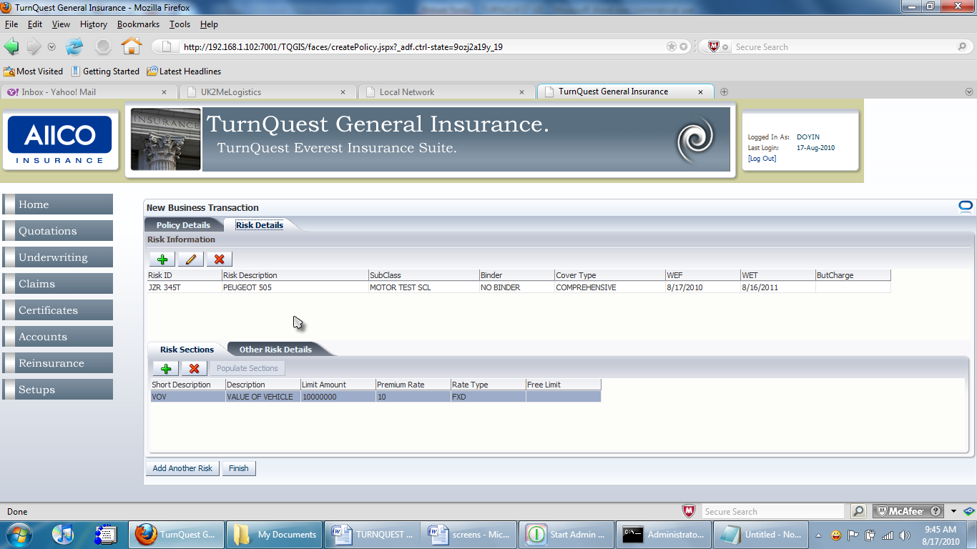 to edit or delete a selected section respectively.
* Click  on the ‘Risk Sections’ pane to proceed to the screen for completing policy data entry.

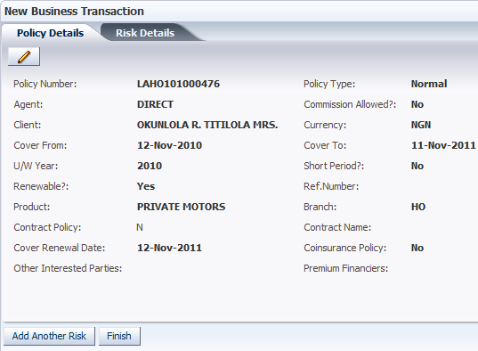

* Click  to go back and edit the policy details captured so far.
* Clickto add another risk to the policy and follow through with the data entry as outlined earlier

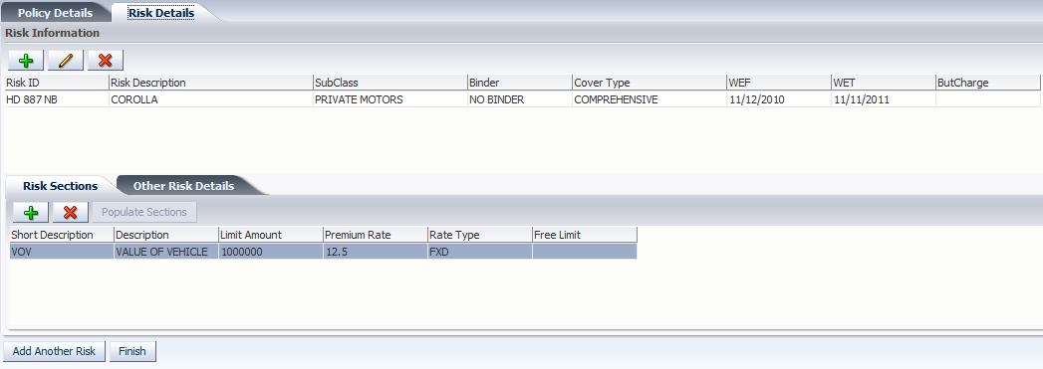

* Click 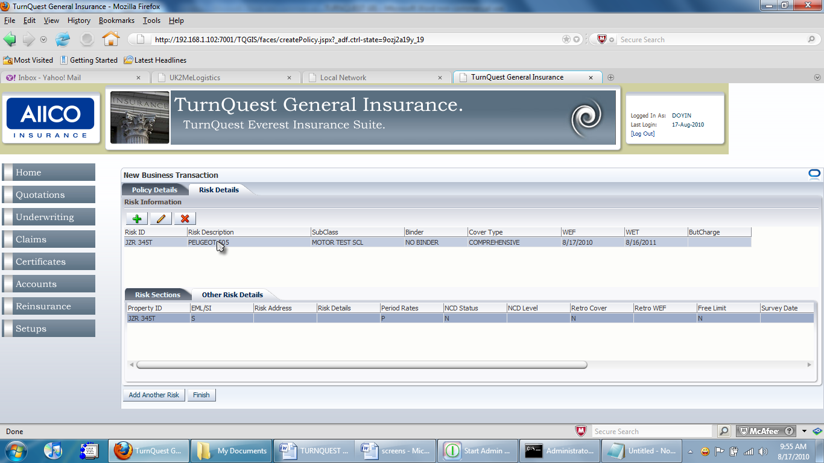 on the data entry completion screen to complete the data entry section for the policy underwriting and proceed to the landing screen

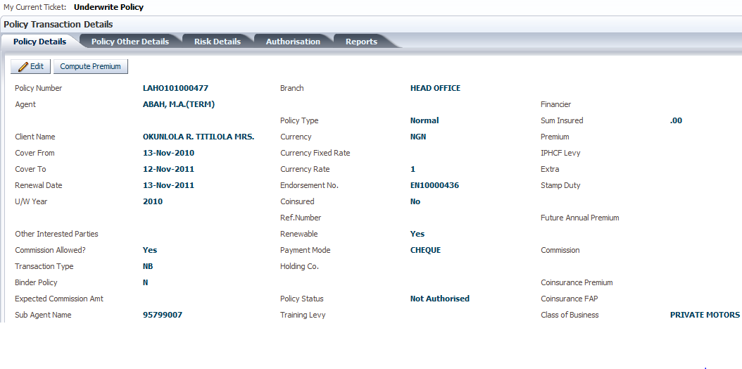

* Click 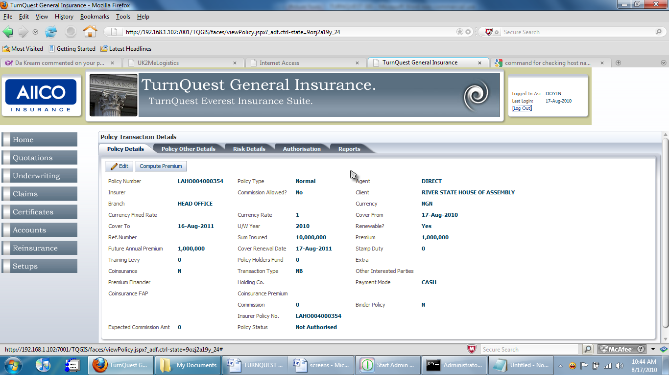 to compute the premium, commissions, co-insurance apportionments, etc.

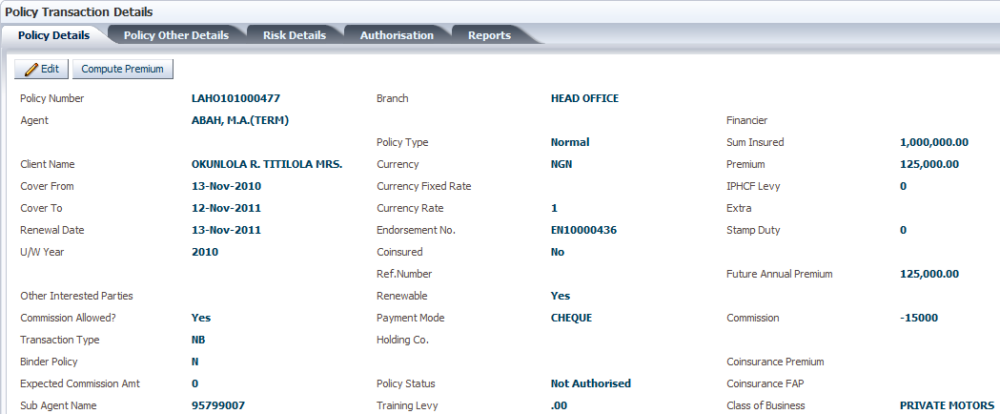

* Select the ‘Policy Other Details’ tab. This reveals the policy details captured on that screen.

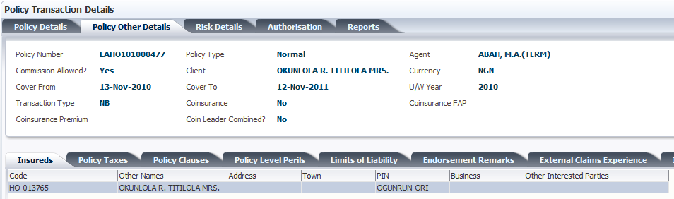

* Click the ‘Policy Taxes’ tab to specify taxes to be charged in the policy

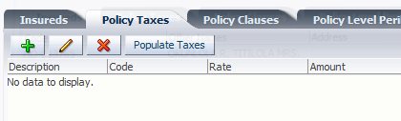

* Click the ‘Policy Clauses’ tab to add and edit clauses to be attached to the policy

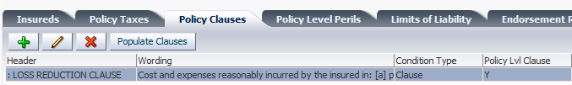

* Click on the ‘Policy Level Perils’ tab to add perils

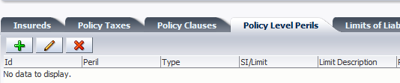

* Click on the ‘External Claims Experience’ tab to add details of claims that the insured has made with other insurers.

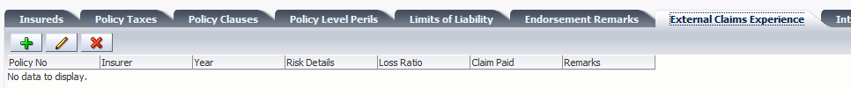

* Click the ‘Internal Claims Experience’ tab to view details of claims that the insured has made with the company.



* Click the ‘Risk Details’ tab to reveal details on the insured, the risks and the risk sections attached in the policy

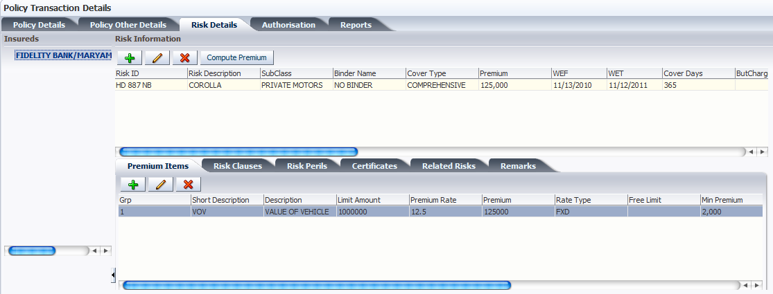

* Use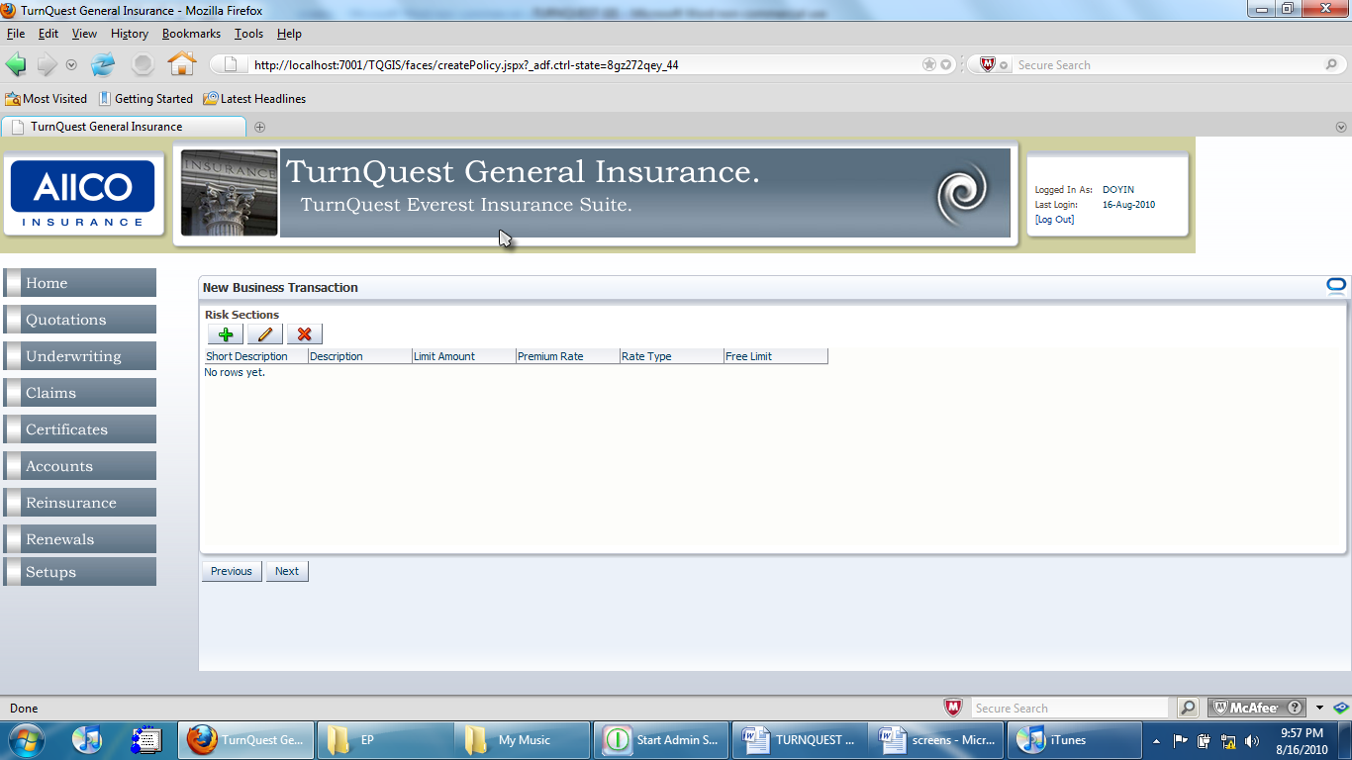,  and  to add, edit and delete risks respectively.
* Click  in the upper section of the ‘Risk Information’ pane to compute premium after making changes to risk premium items or after adding risks and premium items.

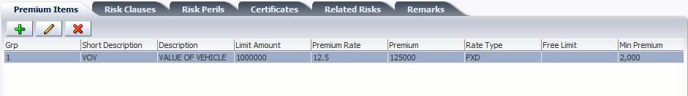

* To edit the risk schedule, scroll to the end of the line of the risk details on the ‘Risk Information’ pane

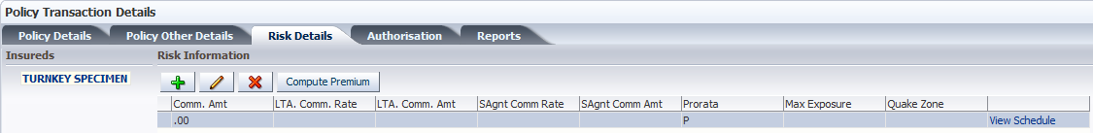

* Click ‘View Schedule’ to bring up the ‘Risk Schedule Details’ screen.

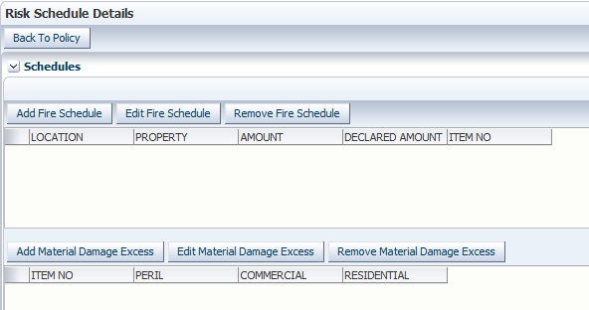

: The screen shows different schedule levels reflecting the levels defined at setup.

* Click  to bring up the dialog box showing the fields set up for the schedule at core setup.

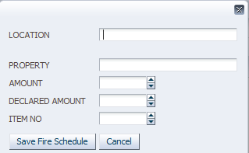

* Enter the details for the various fields and click  to save.
* Click  to go back to the policy underwriting screen.
* Click the ‘Risk Clauses’ tab to view, add or edit the risk clauses

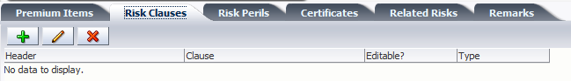

* Click the ‘Risk Perils’ tab to view, add or edit the risk perils

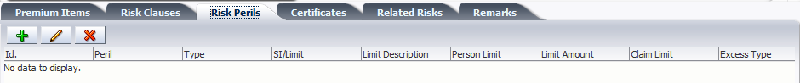

* Click the ‘Certificates’ tab to view, add and edit certificates. The checkbox is used for certificates managed by a regulatory body.

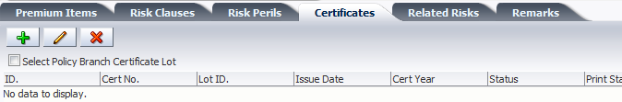

* Click the ‘Related Risks’ tab to view related risks in the same risk group as the selected risk

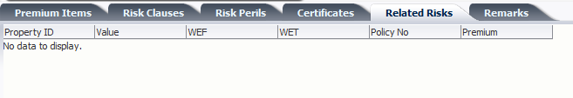

* Click the ‘Remarks’ tab to view, add and edit remarks for the risk.

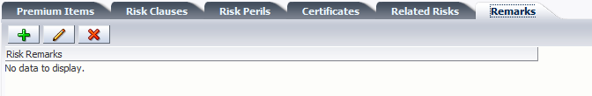

* Click the ‘Authorisation’ tab to proceed to authorizing the policy

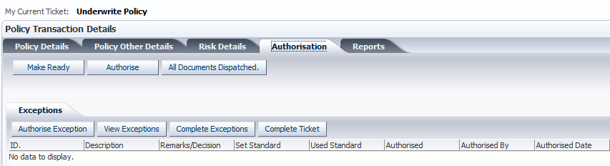

* Click  to make the authorization task available to a user with rights to perform the ask as assigned in CRM. An information box appears to confirm the action

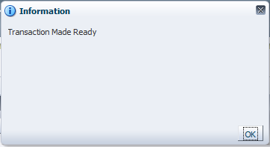

* Click  to authorize the policy, provided the logged-in user has rights to do so. An information box pops up to confirm the action.

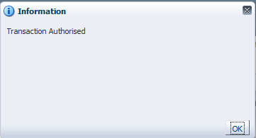

* Click  to dispatch all policy documents.
* On the ‘Exceptions’ tab below the ‘Authorisation’ tab, click,  and  to authorize, view and complete, respectively, exceptions that have been raised.

: When the underwriting process is interrupted, the policy has to be edited to continue. On revisiting the landing screen, the ‘My Current Ticket’ field displays the pending task as at the time of the interruption. When this task is completed, click  to change the ticket status and proceed.

* Click the ‘Reports’ tab to view reports

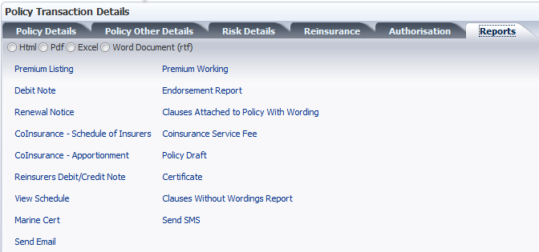

* Select the radio button at the top to indicate which format to view the report
* Click the ‘Premium Working’ link to view the premium working report. This brings up the browser file download dialog box.

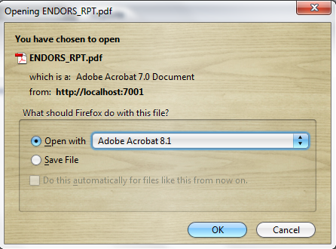

* Click either the ‘Open With’ or ‘Save File’ radio button and click ‘OK’ to open or save the file respectively.

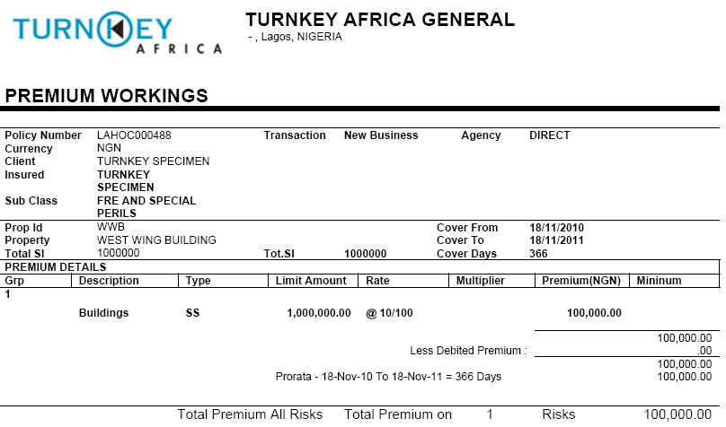

* Click any of the links below to generate the desired report

**Transmittal Payments on a Accrual and Cash Business**

* On NB or EN transaction – Accrual Business

-The process to which a transmittal can be generated for these businesses is a follows:-

* Do a NB / EN transaction
* Print the transmittal receipt to get the barcode Number
* If payment is done before the policy is authorized the receipt amount sits at the policy/ client account for allocation once policy is authorized.
* The transmittal payment here does not auto-authorize the transaction even if there are no pending exception for authorization.

NOTE:-

* Transmittal can be used on a policy that isn’t made ready. And upon completion of the policy allocation is done. In case the draft transaction is deleted the credit is allocated on client account.
* Ensure transmittals used for receipting are only for most active EN or Draft policy and one can never use a previous EN transmittal on receipt.
* On Contract creation – Cash Business

For a contract creation the following are step in working with transmittals:-

* Generate the NB transaction
* Depending on the Payment Frequency used on the policy once the policy is made ready the installment premium expected to activate the contract is displayed on the transmittal report
* If the full installment amount is paid and the contract does not have pending Exception to be authorized then contract is authorized and an EN(installment) created.
* Else if partial payment is done or contract has pending exceptions the receipted amount sits on the client account /Policy await full payment which intern authorizes the policy/contract and creates and endorsement. Where exception prevented for contract authorization once they are authorized one may also use the premium card to process the receipted amount to create an installment.

## Underwriting a Co-Insurance Business Policy

This process is similar to direct and intermediary business policy underwriting except for the introduction of co-insurance partners to the business.

* Click **Home**>>**Underwriting**>>**New Transaction** to bring up the ‘Underwriting Transactions’ screen.



* Click  to bring up a dialog box with a list of transaction types. Select ‘New Business’ and click  to populate the ‘Transaction Type’ field



* Clickto proceed. This brings up the ‘New Business Transaction’ dialog box.



* Click  and select ‘Yes’ or ‘No’ to specify whether the policy is short-period and whether it is renewable.
* Click  after making the selection. This brings up the ‘New Business Transaction’ pane with policy product details.



* To make the business a co-insurance policy, check the ‘Co-insurance Policy’ checkbox
* Click  after entering policy product details to proceed to the ‘Policy Details’ pane



* Populate the fields as described earlier
* Click  to proceed to the ‘Co-Insurance Details’ pane

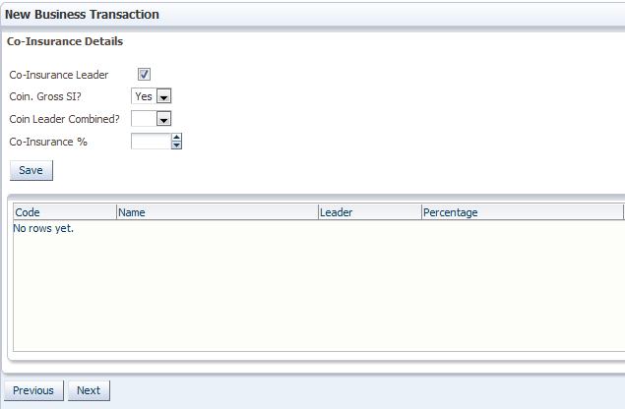

* If the ‘Co-Insurance Leader’ checkbox is unchecked, the ‘Co-Insurance Fee %’ field is generated to indicate the fee that the company will pay to the leader.
* The ‘Coin Gross SI?’ field indicates whether the sum insured captured in the policy is the gross SI or just the company’s share in the co-insurance business. Click  and select ‘Yes’ or ‘No’ from the drop-down list.
* The ‘Coin Leader Combined?’ field indicates whether the company is responsible for handling all premium and claims payment transactions and later settling with co-insurance partners for due remittances afterwards.
* The ‘Co-Insurance %’ field specifies the percentage of the SI our company is liable for.
* Check the ‘Co-insurance Leader’ checkbox if the company is the leader in the co-insurance business

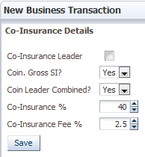

* Click  after populating the above fields. This changes the contents of the block below, showing options for adding co-insurers depending on the inputs in the above fields.

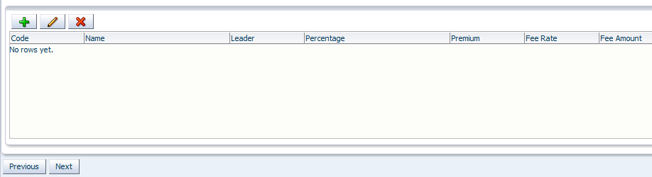

* Click  to bring up the ‘Available Co-Insurers’ dialog box.

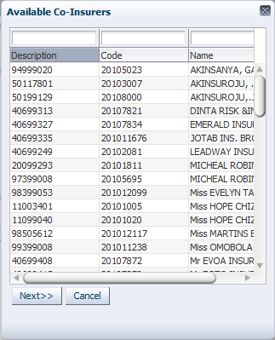

* Select an item from the list and click. This brings up the ‘Co-Insurers Details’ dialog box

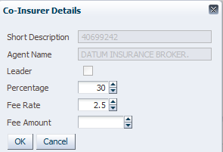

* Click  to save the record.

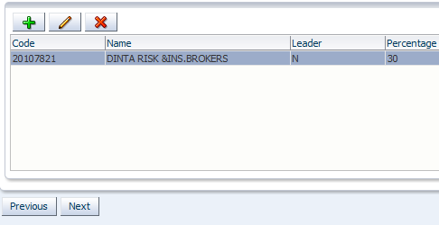

* Click  on the ‘Co-Insurance Details’ pane to proceed to the ‘Risk Details’ pane.
* Proceed through, from the ‘Risk Details’ pane to the landing screen just before finishing data entry to view the co-insurance and risk details

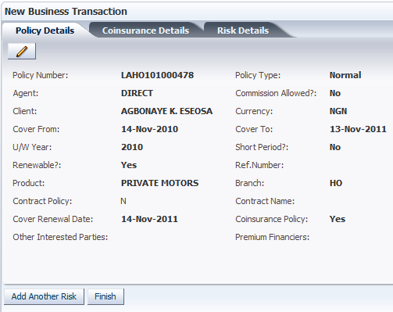

* Click the ‘Co-Insurance Details’ tab to view the co-insurance details

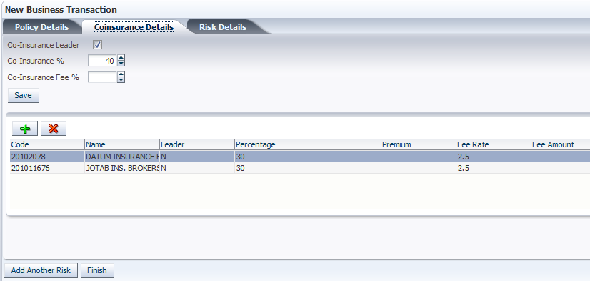

* Click  to complete the data entry section for the policy underwriting and proceed to the landing screen

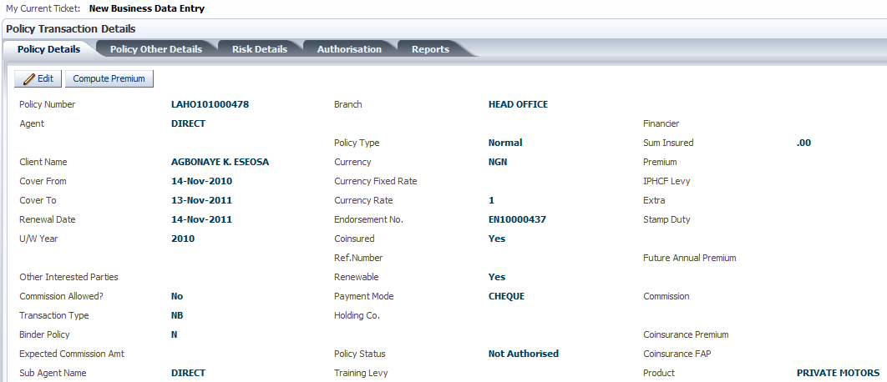

* Click on the **Policy Other Details** >>**Co-Insurance** to view and edit the co-insurance details

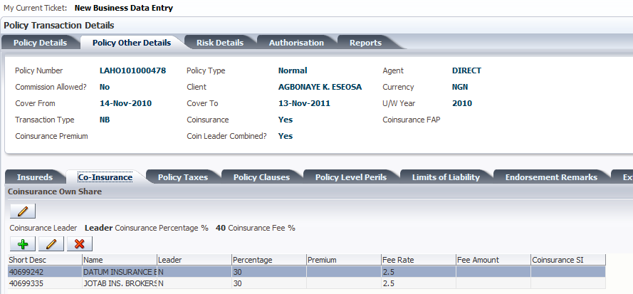

* Authorize the policy as described in direct/intermediary business underwriting as outlined earlier.

## Underwriting a Facultative Inward Business

In facultative inward reinsurance, the company assumes part of a risk insured by a ceding company. Every risk taken up by the company is negotiated separately with the ceding company.

* Click **Home**>>**Underwriting**>>**New Transaction** to bring up the ‘Underwriting Transactions’ screen.



* Click  to bring up a dialog box with a list of transaction types. Select ‘New Business’ and click  to populate the ‘Transaction Type’ field



* Clickto proceed. This brings up the ‘New Business Transaction’ dialog box.



* Click  and select ‘Yes’ or ‘No’ to specify whether the policy is short-period and whether it is renewable.
* Click  after making the selection. This brings up the ‘New Business Transaction’ screen with the ‘Policy Product Details’ pane.

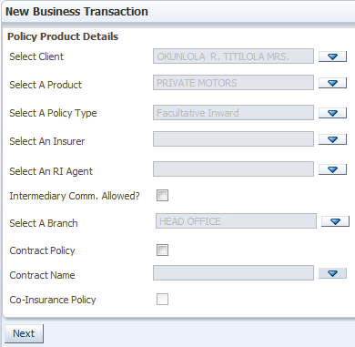

* Click  for the ‘Select A Policy Type’ field to bring up the dialog box with a list of policy types.



* Select the ‘Facultative Inward’ policy type and click 
* Click  on the ‘Policy Product Details’ pane to proceed to the ‘Risk Details’ pane and then from the ‘Risk Details’ pane to the policy data entry completion screen asshown earlier.

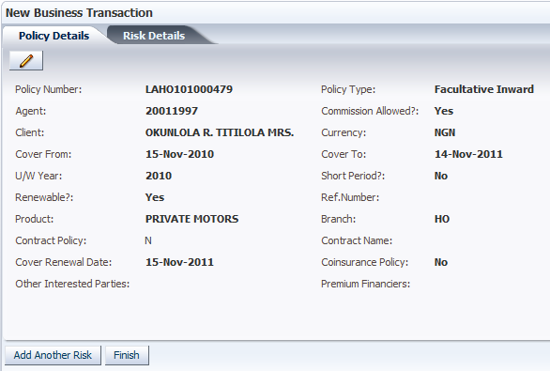

* Click  to complete the data entry section for the policy underwriting and proceed to the landing screen

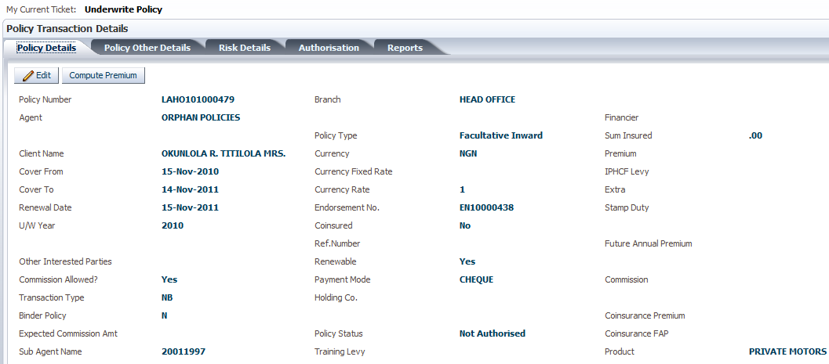

* Click on the **Policy Other Details** >>**Facre-In Details** tabsto add the facultative inward details

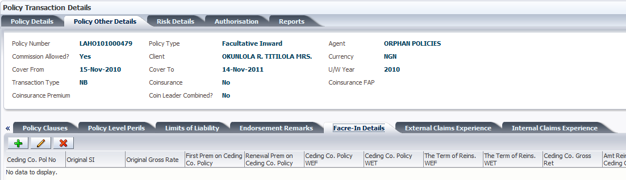

* Click. This brings up the ‘Facre-In Details’ dialog box

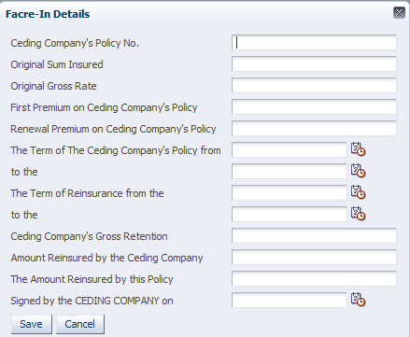

* Click to bring up the calendar and select the dates to populate the respective fields for dates.
* Click 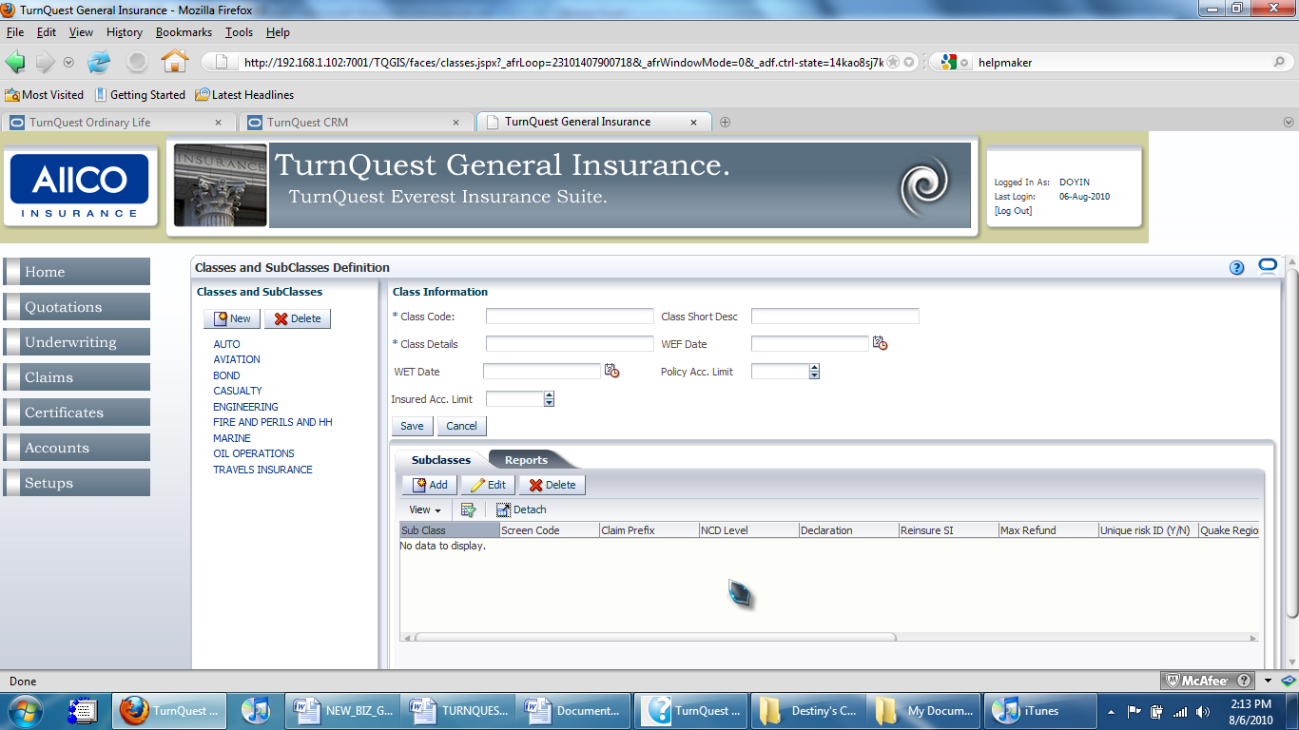 to save the facre-in details
* Authorize the policy and dispatch documents as outlined earlier in direct/intermediary business underwriting.
* Click on the ‘Reports’ tab

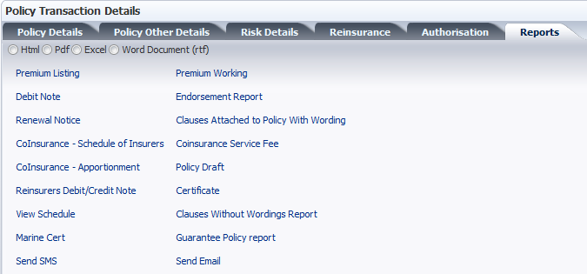

* Click on the ‘Guarantee Policy Report’ to generate the guarantee policy to be sent to the ceding company.

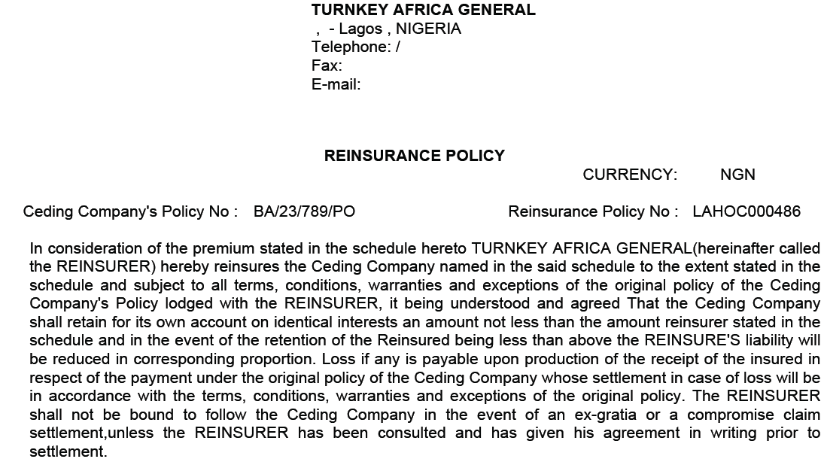

# RISK VALUATION/SURVEY

* On the main menu panel, click **Underwriting**>>**Risk Valuation/Survey**. This brings up the ‘Survey And Valuation Processing’ screen.

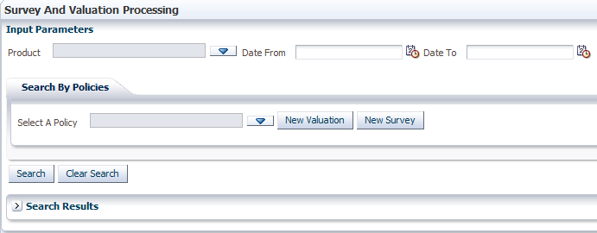

* To narrow the search by the product, click  for the ‘Select Product’ field to bring up the ‘Select Products’ dialog box.
* Select the product and click  to populate the ‘Select Product’ field.
* Click  for both the ‘Date From’ and ‘Date To’ fields to specify the period within which the policy was underwritten.
* To search for the policy using the policy number, click  for the ‘Select A Policy’ field to bring up the ‘Select Policy’ dialog box containing a list of policies in the system.
* Paste or type in the policy number or client name in the search box above the ‘Policy No.’ or ‘Client’ column to narrow the search. Alternatively, scroll through the list to find the policy.

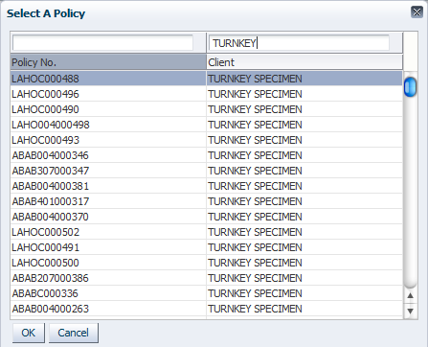

* Select a record and click  to populate the ‘Select A Policy’ field

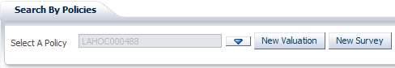

: Valuations are done strictly for motor class businesses while surveys are done for non-motor businesses.

* Click  or  to perform a valuation or a survey respectively. This brings up the ‘Valuation Information’ pane.

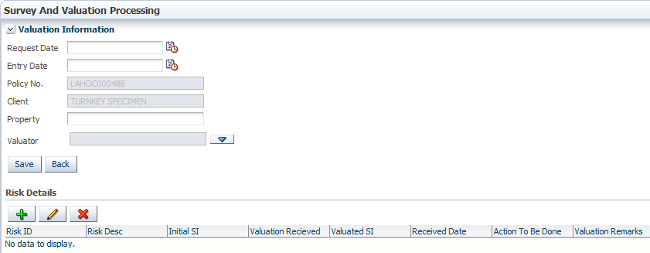

* The ‘Request Date’ is the day the survey was requested.
* The ‘Entry Date’ is the day the survey details are captured in the system.
* The ‘Policy No.’ and ‘Client’ fields are automatically populated.
* The ‘Property’ field specifies the name of the risk/property to be evaluated.
* The ‘Valuator’ field specifies the valuator to be appointed.
* Click  for the ‘Valuator’ field to bring up the ‘Valuator’ dialog box with a list of valuators

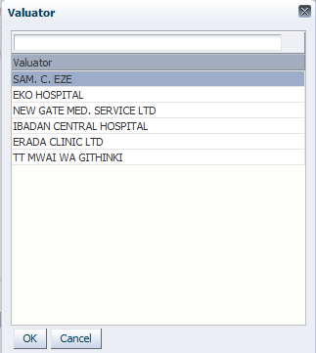

* Select an item and click  to populate the field.
* Click  to save the survey details captured.
* In the ‘Risk Details’ section below, click. This brings up the ‘Risks’

# ENDORSEMENTS

An endorsement is done when there is a change to a policy that is already in force after an instruction from the client/broker or co-insurance leader (in case of a coinsurance).

1. ***Revision of Cover***

A revision of cover endorsement is done on the following grounds:

* Increase of sum insured on existing risks in the policy
* Addition of a new risk in the policy
* Extension of individual risk cover periods
* Upward revision of premium rate
* Withdrawal of discounts rates
* Inclusion of loading rates

In the system, an endorsement can only be done on a policy which has been authorized in the system.

* Click **Home** >>**Underwriting** >>**New Transaction**. This brings up the ‘Underwriting Transactions’ screen with the ‘Input Parameters’ pane

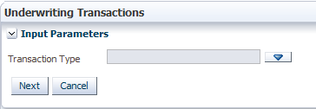

* Click  for the ‘Transaction Type’ field to bring up the dialog box with the list of transaction types

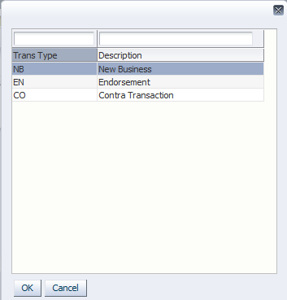

* Select ‘Endorsement’ and click  to proceed. This generates more fields in the ‘Input Parameters’ pane.

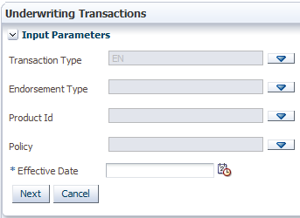

* Click  for the ‘Endorsement Type’ field to bring up the ‘Endorsement Type’ dialog box

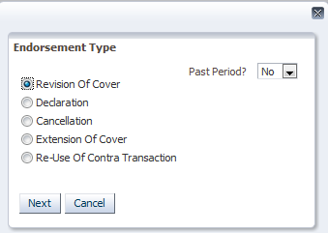

* The ‘Revision of Cover’ button is selected by default. Click it otherwise.
* Click  to populate the ‘Endorsement Type’ field
* Click  for the ‘Product Id’ field to bring up the ‘Select Product’ dialog box

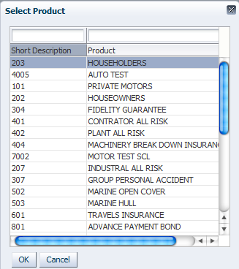

* Select the product for which the intended policy to be endorsed was underwritten and click  to populate the ‘Product Id’ field.
* Click  for the ‘Policy’ field to bring up the ‘Select Policy’ dialog box

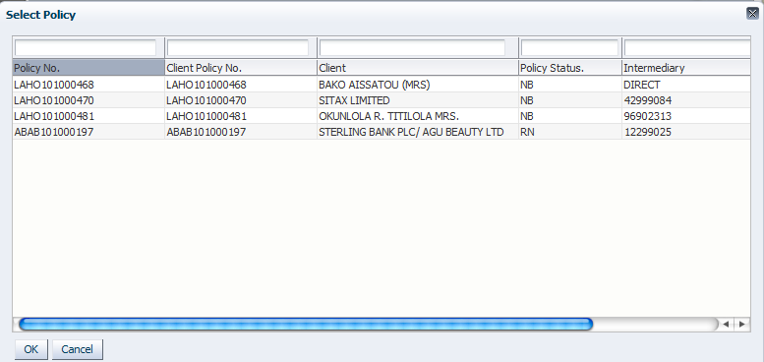

* Select a policy after identifying it with policy details from the authorized policy to be endorsed.
* Click  for the ‘Effective Date’ field and select a date from the calendar. This indicates the date from which the endorsement is to take effect.
* Click  to proceed to the policy underwriting landing screen.

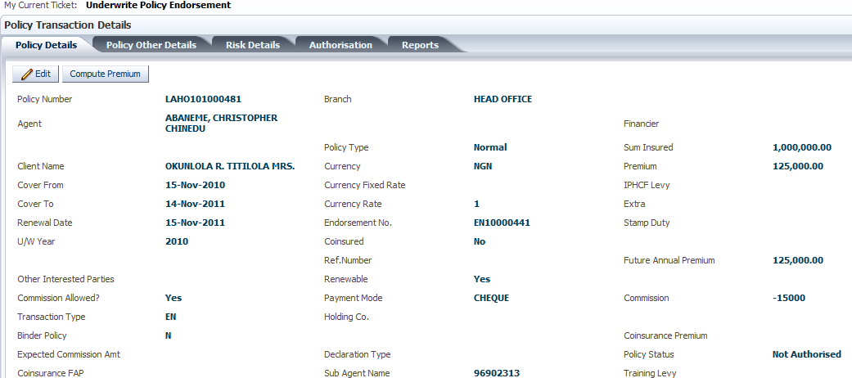

* Click the ‘Risk Details’ tab to access the ‘Insureds’ and ‘Risk Information’ screens

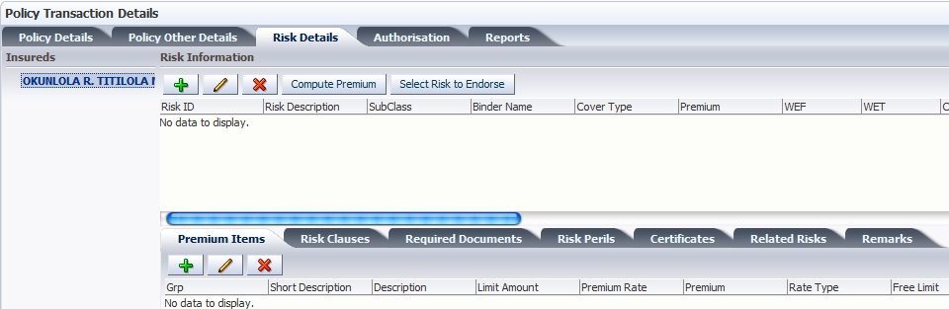

* Select the insured whose risks are to be reviewed
* Click  to bring up the ‘Endorsement’ screen with the ‘Insureds’ and ‘Risk Information’ panes.

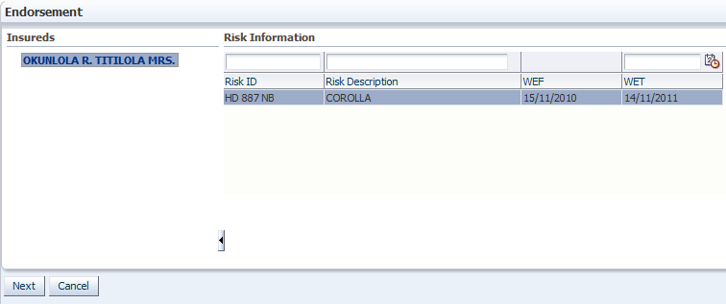

* Select the risk to endorse on the ‘Risk Information’ pane and click  go back to the ‘Risk Details’ tab on the ‘Policy Transaction Details’ screen

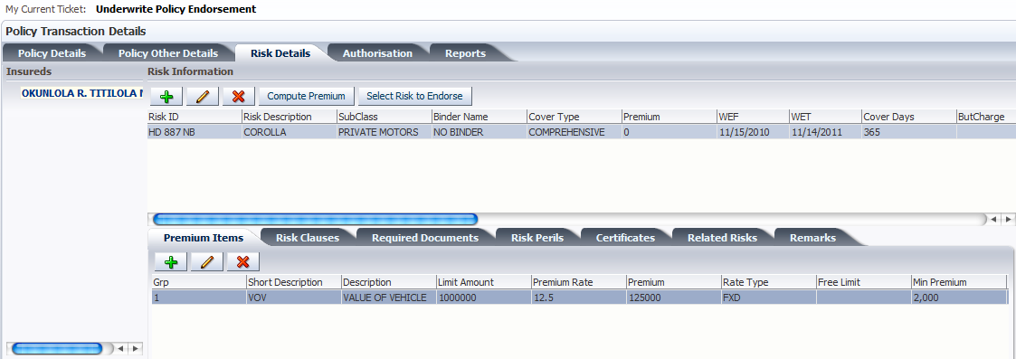

* Edit the risks and premium items as outlined in the new business underwriting section.
* Click  to compute the premium after changing risk and premium items details.
* To add endorsement wordings, click on the ‘Endorsement Remarks’ tab under the ‘Policy Other Details’ tab

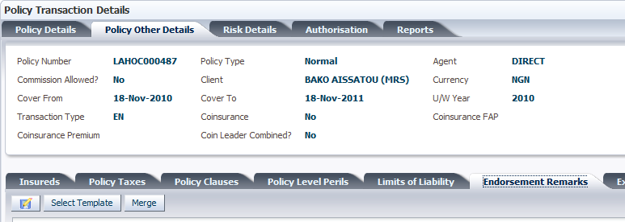

* Click  to select from the list of templates defined at setup.

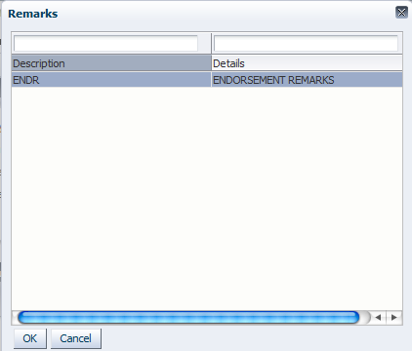

* Select a template and click. This populates the pane with the wording of the template.

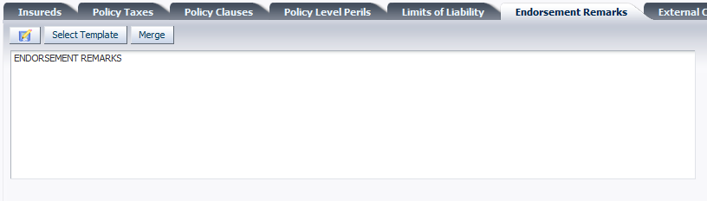

* Click  to populate merge fields in the wordings.
* Edit the wording as needed and click  to save.
* Authorize the policy endorsement as earlier outlined.
* Click the ‘Reports’ tab

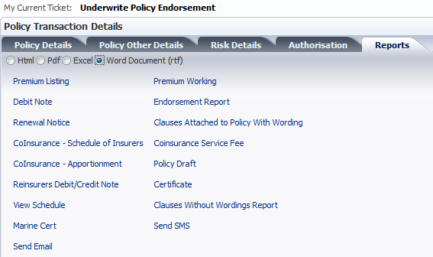

* Select the document format type and click the ‘Endorsement Report’ link to view the endorsement report. This brings up the browser file download dialog box.



* Click either the ‘Open With’ or ‘Save File’ radio button to open or save the file respectively.

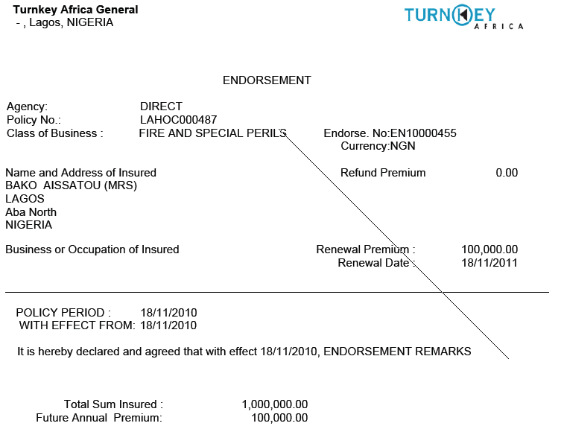

1. ***Extension of Cover***

An extension of cover endorsement is done when a policy expiry period is due and the client wishes to extend the policy for a short term, instead of renewing the policy.

* Click **Home** >>**Underwriting** >>**New Transaction**. This brings up the ‘Underwriting Transactions’ screen with the ‘Input Parameters’ pane



* Click  for the ‘Transaction Type’ field to bring up the dialog box with the list of transaction types



* Select ‘Endorsement’ and click  to proceed. This generates more fields in the ‘Input Parameters’ pane.

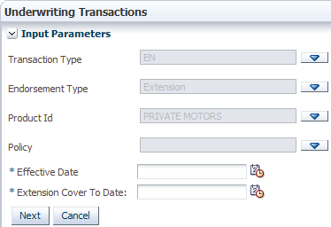

* Click  for the ‘Endorsement Type’ field to bring up the ‘Endorsement Type’ dialog box



* Click the ‘Extension of Cover’ button.
* Click  to populate the ‘Endorsement Type’ field
* Click  for the ‘Product Id’ field to bring up the ‘Select Product’ dialog box



* Select the product for which the intended policy to be endorsed was underwritten and click  to populate the ‘Product Id’ field.
* Click  for the ‘Policy’ field to bring up the ‘Select Policy’ dialog box



* Select a policy after identifying it with policy details from the authorized policy to be endorsed.
* Click  for the ‘Effective Date’ field and select a date from the calendar. This indicates the date from which the endorsement is to take effect.
* Click  for the ‘Extension Cover To Date’ field and select a date from the calendar. This indicates the date up to when the cover is active
* Click  to proceed to the policy underwriting landing screen.



* Click the ‘Risk Details’ tab to access the ‘Insureds’ and ‘Risk Information’ screens

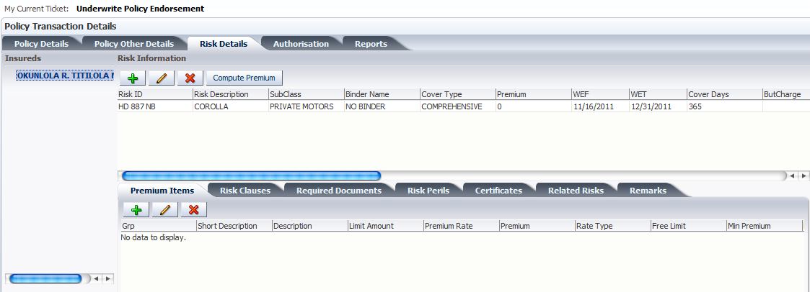

* Select the insured whose risks are to be reviewed
* Edit the risks and premium items as outlined in the new business underwriting section.
* Click  to compute the premium after changing risk and premium items details.
* Authorize the policy endorsement and dispatch policy documents as earlier outlined.
* Click the ‘Reports’ tab



* Select the document format type and click the ‘Endorsement Report’ link to view the endorsement report. This brings up the browser file download dialog box.

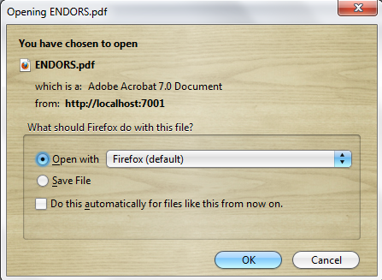

* Click either the ‘Open With’ or ‘Save File’ radio button to open or save the file respectively.
* Click the ‘Endorsement Report’ link to see the endorsement report

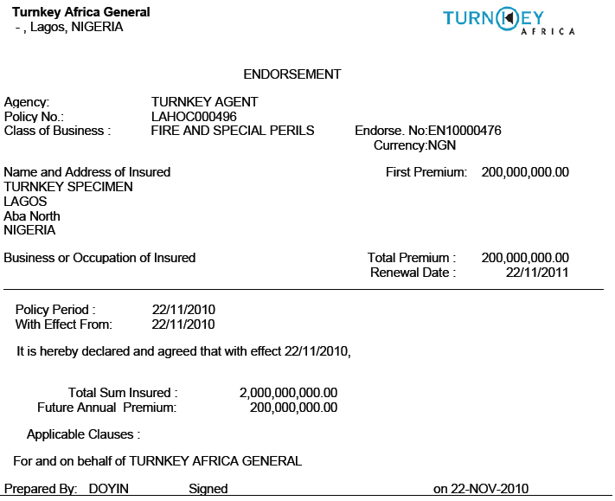

* To view the debit/credit note, depending on what type of transaction is done in finance, click the ‘Debit Note’ link

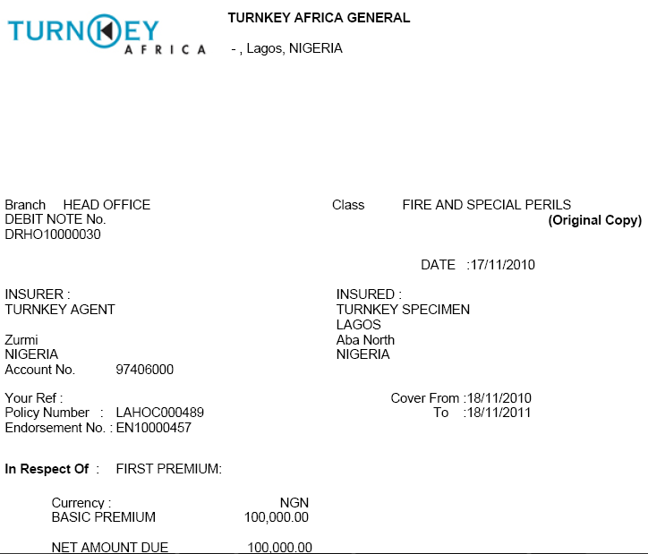

1. ***Policy Cancellation***

Cancellations can be done on the following grounds:

* Non-payment of premiums.
* Request by the client.
* If the insurer feels it’s not profitable to continue with the same cover
* Click **Home** >>**Underwriting** >>**New Transaction**. This brings up the ‘Underwriting Transactions’ screen with the ‘Input Parameters’ pane



* Click  for the ‘Transaction Type’ field to bring up the dialog box with the list of transaction types



* Select ‘Endorsement’ and click  to proceed. This generates more fields in the ‘Input Parameters’ pane.



* Click  for the ‘Endorsement Type’ field to bring up the ‘Endorsement Type’ dialog box



* Click the ‘Cancellation’ radio button
* Click  to populate the ‘Endorsement Type’ field

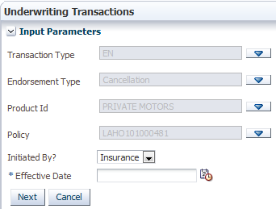

* Click  for the ‘Product Id’ field to bring up the ‘Select Product’ dialog box



* Select the product for which the intended policy to be endorsed was underwritten and click  to populate the ‘Product Id’ field.
* Click  for the ‘Policy’ field to bring up the ‘Select Policy’ dialog box



* Select a policy after identifying it with policy details from the authorized policy to be endorsed.
* Click  and select ‘Insurance’ or ‘Client’ to indicate which party called for the cancellation.
* Click  for the ‘Effective Date’ field and select a date from the calendar. This indicates the date from which the endorsement is to take effect.
* Click  to proceed to the policy underwriting landing screen.



* Click  to compute the refund premium.

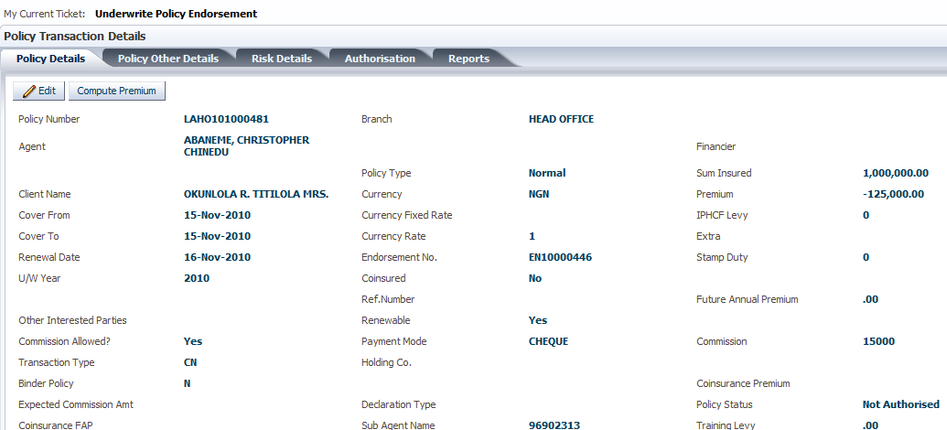

* Click the ‘Risk Details’ tab to access the ‘Insureds’ and ‘Risk Information’ screens



* Select the insured whose risks are to be reviewed
* Authorize the policy endorsement and dispatch documents as earlier outlined.
* Click the ‘Reports’ tab



* Click on the ‘Debit Note’ link to view the credit note raised in finance.

1. ***Contra Transaction***

As an audit measure, every transaction authorised in the TurnQuest GIS system cannot be altered. To reverse any changes done by a particular transaction, the system provides Contra Transactions that have the effect of entirely reversing the effect of a transactions and returning it to a previous status.

* The system provides for the reversal of any authorized transactions.
* All authorised records will become permanent and cannot be altered in any way.

The order of transaction entry must be maintained (that is, if a policy has three endorsements and the entry to be reversed is the second transaction, then the third transaction should be reversed first to give way to reversing the second transaction. This is so because the third transaction may have been based on the second transaction).

* Click **Underwriting** >>**New Transaction**. This brings up the ‘Underwriting Transactions’ screen with the ‘Transaction Type’ screen.

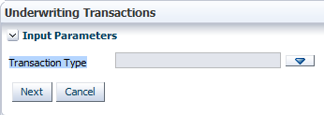

* Click  to bring up the dialog box with a list of transaction types

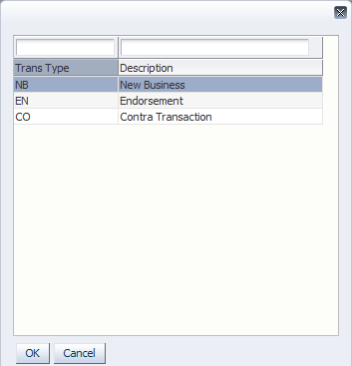

* Select ‘Contra Transaction’ and click  to populate the ‘Transaction Type’ field

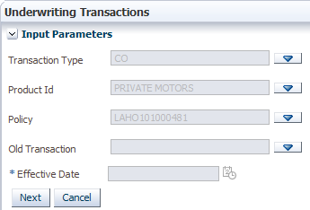

* Click  for the ‘Product Id’ field to bring up the ‘Select Product’ dialog box



* Select the product for which the intended policy to be endorsed was underwritten and click  to populate the ‘Product Id’ field.
* Click  for the ‘Policy’ field to bring up the ‘Select Policy’ dialog box



* Select a policy after identifying it with policy details from the authorized policy to be endorsed.
* Click  for the ‘Old Transaction’ field to select the transaction to be reversed. This brings up a dialog box with a list of transactions that have been authorized on the selected policy

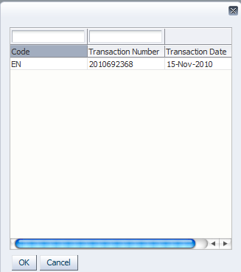

* Select the transaction to reverse and click  to populate the ‘Old Transaction’ field
* Click  to proceed.

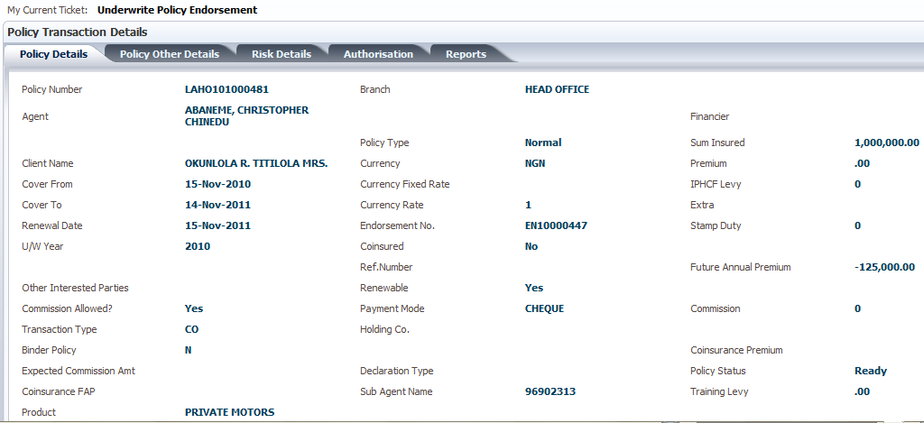

* Authorize and dispatch policy documents as outlined earlier.

1. ***Re-Use of Contra Transaction***

In the event that a contra transaction is done, the user has the option of using the details of the transaction captured. For example, if a contra transaction is done on a policy, doing a re-use of contra transaction allows the user redo the policy using all the details of the old transaction, including the policy number.

: This can only be done on a new business transaction that has been authorized and on which a contra transaction has been done and authorized.

* On the main menu panel, click **Underwriting**>>**New Transaction** to bring up the ‘Underwriting Transactions’ screen.

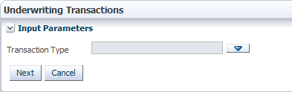

* Click  to bring up the dialog box with a list of transaction types

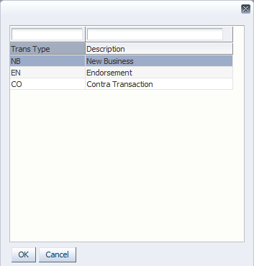

* Select ‘Endorsement’ and click  to populate the ‘Transaction Type’ field on the ‘Input Parameters’ pane.
* Click  to generate more fields on the ‘Input Parameters’ pane

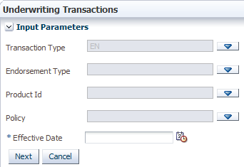

* Click  for the ‘Endorsement Type’ field to bring up the ‘Endorsement Type’ dialog box

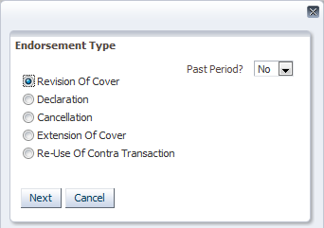

* Select the ‘Re-Use Of Contra transaction’ radio button
* Click  to Populate the ‘‘Endorsement Type’ field’
* Click  for the ‘Product Id’ field to bring up the ‘Select Product’ dialog box

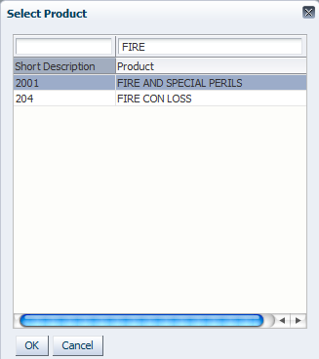

* Select the desired product and click  to populate the ‘Product Id’ field.
* Click  for the ‘Policy’ field to bring up the ‘Select Policy’ dialog box

: Only policies which match the criteria in the previous note will be displayed here.

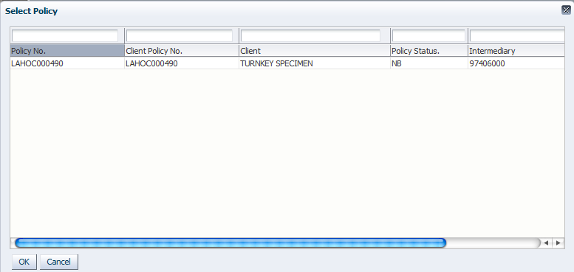

* Select the desired policy and click  to populate the ‘Policy’ field.
* Clickand select the effective date of the endorsement from the calendar to populate the ‘Effective Date’ field.
* Click  to proceed to the policy underwriting landing screen.

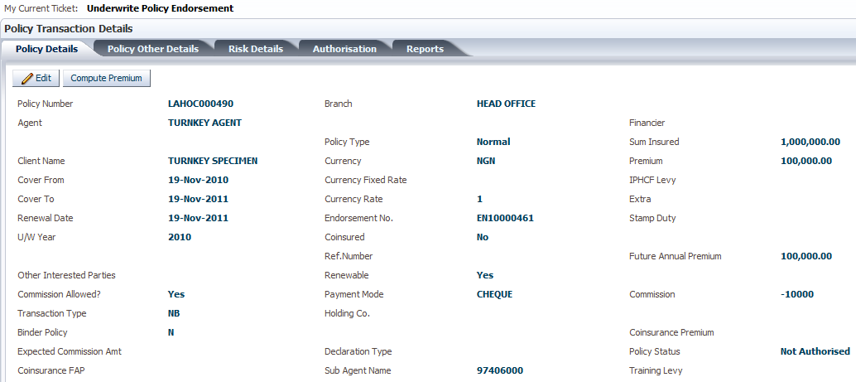

: The same details of the policy on which a contra transaction was done are displayed here.

* Edit the policy and risk details as required, adding endorsement wordings as outlined earlier.
* Authorize and dispatch documents as earlier outlined.
* Click on the ‘Reports’ tab to view the endorsement report.

1. ***COMESA/ECOWAS ENDORSEMENT***

* This endorsement depends on the region to which the business is offered.

To do a COMESA Endorsement select a new transaction by the type Endorsement and select the COMESA Endorsement field to **Yes** this check ensures commission is not computed on a Comesa Premium

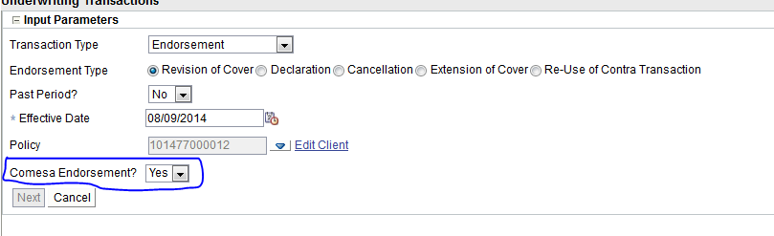

On hit of the **Next** Button select the insured and the risks to do Comesa EN on.

Check on the risk **Checkbox** to Select the risk

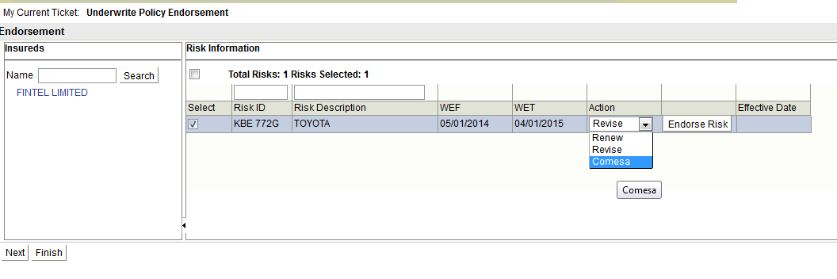

Then select the action to **Comesa.** A dialog boxpops on which the subclass Comesa is selected the Cover type and the risk Period which is used to compute Premium.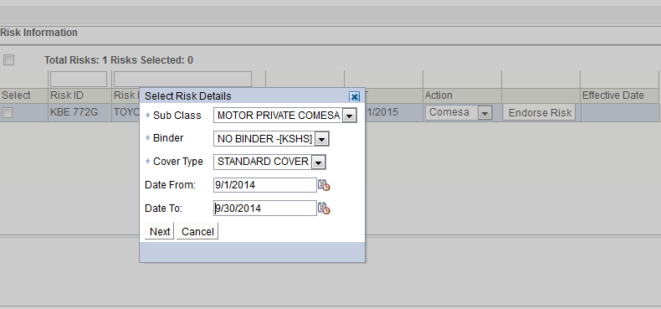

1. ***Binder Endorsement***

For a binder endorsement risks are to be renewed and revised on a one by one basis. To achieve this start out a normal endorsement>>hit finish without having selected a risk the on the risk details screen select the button Binder Risk Endorsement

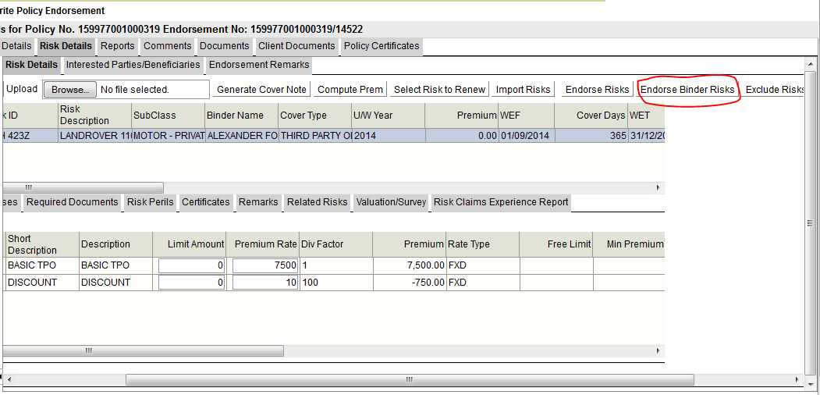

On selection of this a dialog box appears to enable for the selection of risk with the action type

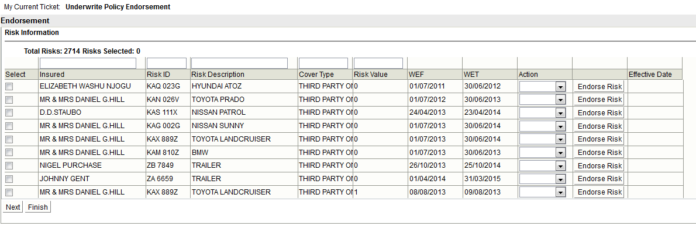

At risk selection on has two options to move with the risks :-

1. Check on the risk checkbox to select all the risks then hit **Next**
2. Select on the risk and hit the **Endorse Risk**

# POLICY RENEWAL

After the cover period for a policy comes to an end, it is renewable depending on the client/broker.

* On the main menu panel, click **Underwriting**>>**Renewal Processing** to bring up the ‘Renewals Processing’ screen with the ‘Select A Renewal Transaction’ pane below it.

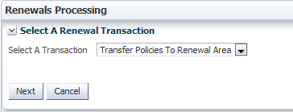

* Click  for the ‘Select A Transaction’ field and select an option.

: Select ‘Transfer Policies To Renewal Area’ to select policies and prepare them for renewal or select ‘Process Policies In Renewal Area’ to process policies already prepared for renewal.

* Click  to proceed to the ‘Select A Search Criteria’ pane

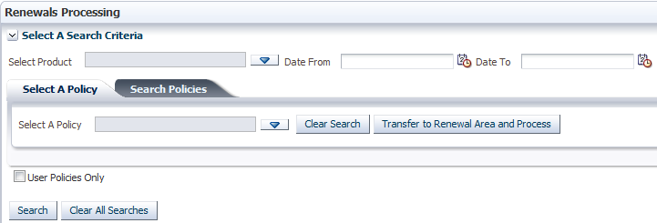

* The search can be narrowed by product as outlined in ‘Policy Lapsing’.
* Click  for the ‘Select A Policy’ field to bring up the ‘Select Policy’ dialog box containing a list of policies in the system.
* Check the ‘User Policies Only’ checkbox to show only policies prepared by the currently logged-in user in the search results.

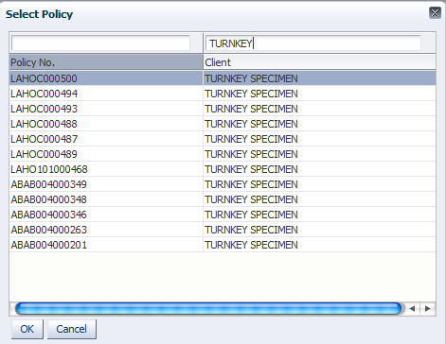

* Select a policy and click  to populate the field.

: The search on the ‘Select A Policy’ tab is done to retrieve a single policy. Search for multiple policies is done on the ‘Search Policies’ tab.

* Click  to move directly to the policy underwriting landing screen.

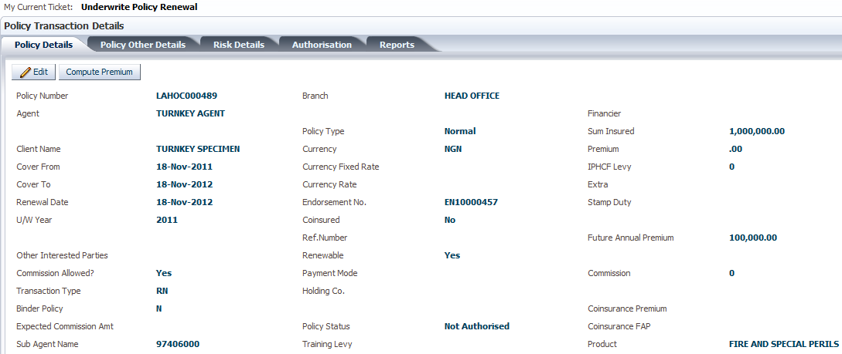

* To search for and process multiple policies, click the ‘Search Policies’ tab

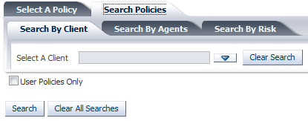

: Policies can be searched for by client, agent and risk on the ‘Search By Client’, ‘Search By Agents’ and ‘Search By Risk’ tabs respectively.

* Click the ‘Search By Client’ tab to search by client.
* Click  for the ‘Select A Client’ field

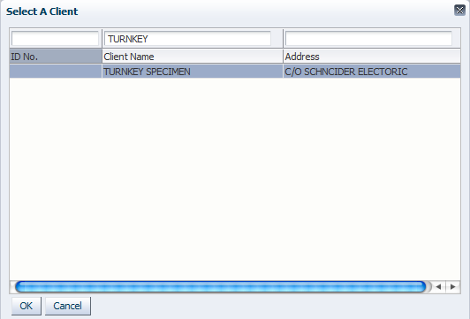

* Select a client and click  to populate the field.
* Click  to generate the list of policies belonging to the selected client.

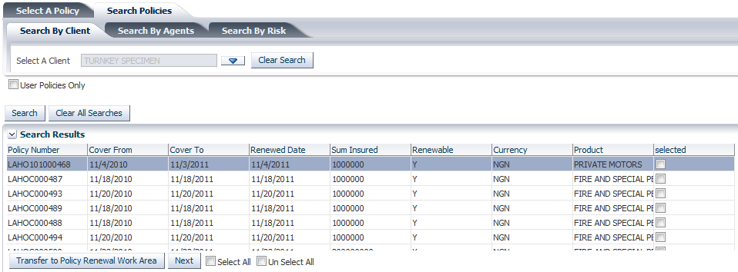

* Select the policies (using the checkboxes on the ‘Selected’ column) to be transferred to the renewal area and click  to transfer the selected policy to the renewal work area.
* Click  to transfer the selected policy to the renewal area. This brings up the renewal area screen.
* Search for policies in the renewal area in the same way as outlined earlier.

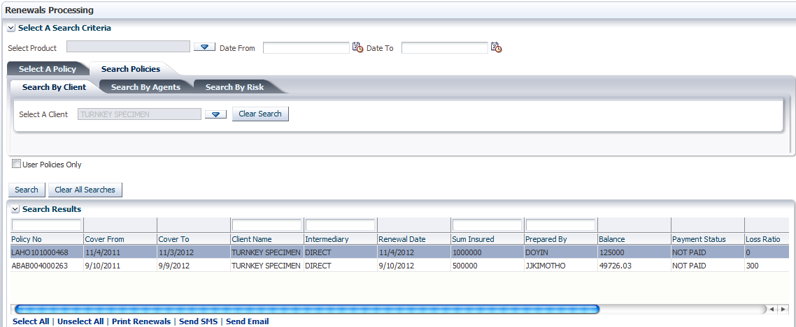

* Click on the ‘Print Renewals’ link to print the renewal report.
* Scroll to the end of the listed items to see the remaining policy details.

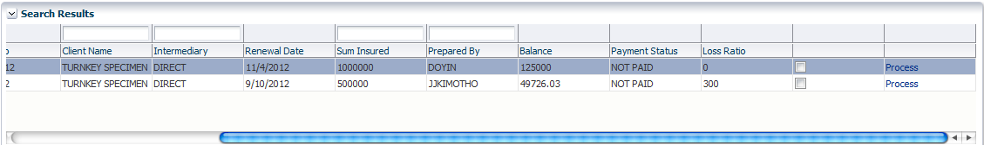

* Click on the ‘Process’ link in the last column of the policy details. This brings up the ‘Ticket Information’ dialog box

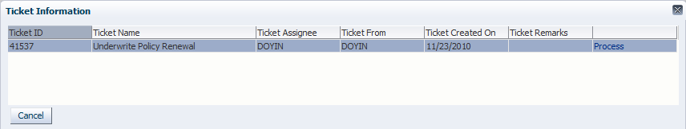

* Click on the ‘Process’ link in the last column of the ticket details. This brings up the ticket processing screen.

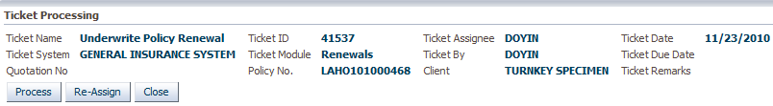

* Click  to process the ticket or  to assign the ticket to another user.

: Clicking  brings up the policy underwriting landing screen.

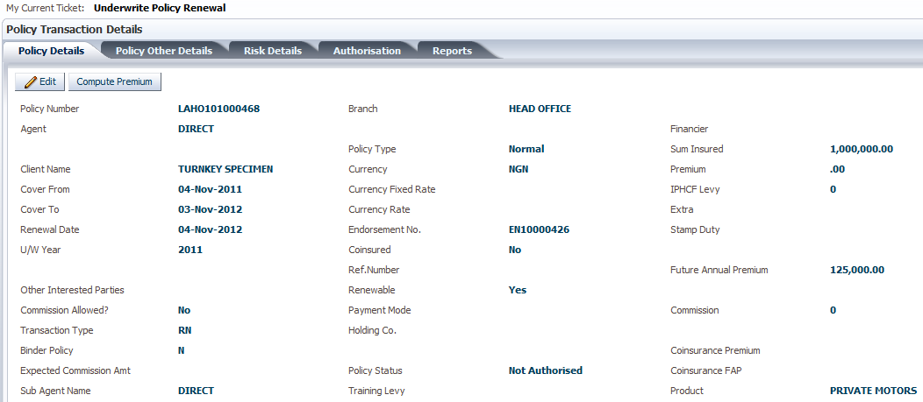

* Compute the premium, authorize the renewed policy, dispatch documents and print reports as earlier outlined.
* To search for policies by agents, click the ‘Select By Agents’ tab
* Click  for the ‘Select An Agent’ field

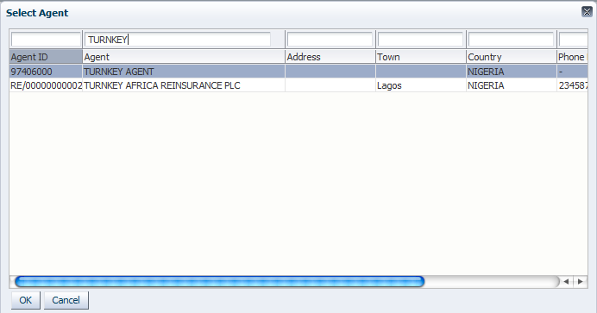

* Select an agent and click  to populate the field.
* Search for and process the policies in the same way as outlined after searching by client.
* To search for policies by risk, click the ‘Search By Risk’ tab

# POLICY LAPSING

This transaction is meant for expired policies (not renewed) and due for lapsation as per company policies.

* On the main menu panel, click **Underwriting**>>**Lapse Policies**. This brings up the ‘Lapsed Policies’ screen.

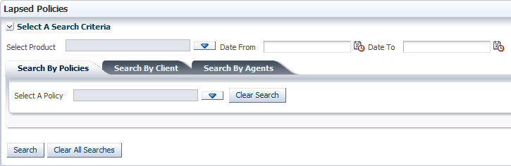

: There are different criteria on the ‘Select A Search Criteria’ pane with which to search for the policy to be lapsed.

* To narrow the search by the product, click  for the ‘Select Product’ field to bring up the ‘Select Products’ dialog box.
* Select the product and click  to populate the ‘Select Product’ field.
* Click  for both the ‘Date From’ and ‘Date To’ fields to specify the period within which the policy was underwritten.
* To search for the policy using the policy number, select the ‘Search By Policies’ tab.
* Click  for the ‘Select A Policy’ field to bring up the ‘Select Policy’ dialog box containing a list of policies in the system.
* Paste or type in the policy number or client name in the search box above the ‘Policy No.’ or ‘Client’ column to narrow the search. Alternatively, scroll through the list to find the policy.

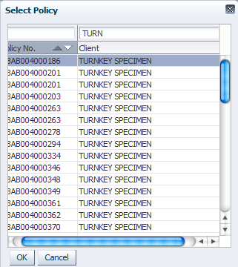

* Select a record and click  to populate the ‘Select A Policy’ field

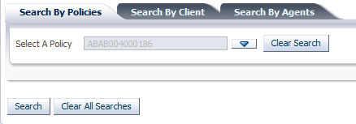

* Click  to generate results for the search results.

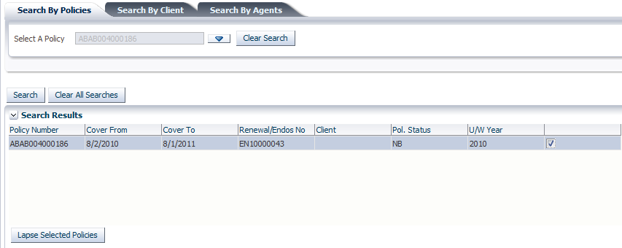

* Check the checkbox attached to the desired policy or policies.

: Depending on the search criteria, several policies may be generated from the search. Multiple policies can be selected and lapsed at the same time.

* Click  to lapse the policies selected.
* On RN transaction – Accrual
* When a policy is due for renewal it has to be transferred to the renewal work area where a Renewal Notice is printed. The renewal Notices carries with it the barcode/transmittal which can be used to make payment while the policy sit in the work Area.
* If full payment of the FAP is done the while at the renewal work area the credit sits onto the policy awaiting been transferred to UW and authorization of the policy auto-allocation is done.

Note:-

* Transmittal on a policy to be renewed may be captured from renewal Notice or Debit Note this is while the policy is in the renewal work area or if transferred to UW.
* On RN Transaction – Cash

For cash basis RN such as PA based on the payment frequency RN the transmittal may be used differently;-

* For the frequencies Monthly, Semi-annual, and Quarterly basis the transmittal is captured from the most active contract i.e. NB, RN or ME.
* While for the annual frequency the business is treated similar to an Accrual RN process as above.
* Not For the type of transaction a flow to show all Receipting done can be achieved at the Premium card using the Contracts i.e. NB and RN transactions. In turn one also has a listing of all EN (Installments) paid for after receipting

NOTE:-

* Transmittal printed are only captured for the active contract only for Cash basis(Monthly, Quarterly and Semi-annual contracts) while for Annual the most active EN or on the draft transaction transmittal can be printed.

# POLICY REINSTATEMENT

This process is done for policies which have been cancelled or lapsed.

* On the main menu panel, click **Underwriting**>>**Reinstate Policy** to bring up the ‘Reinstate Policies’ screen

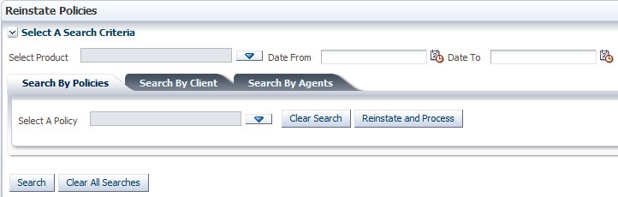

: There are different criteria on the ‘Select A Search Criteria’ pane with which to search for the policy to be reinstated.

* To narrow the search by the product, click  for the ‘Select Product’ field to bring up the ‘Select Products’ dialog box.
* Select the product and click  to populate the ‘Select Product’ field.
* Click  for both the ‘Date From’ and ‘Date To’ fields to specify the period within which the policy was underwritten.
* To search for the policy using the policy number, select the ‘Search By Policies’ tab.
* Click  for the ‘Select A Policy’ field to bring up the ‘Select Policy’ dialog box containing a list of cancelled policies.

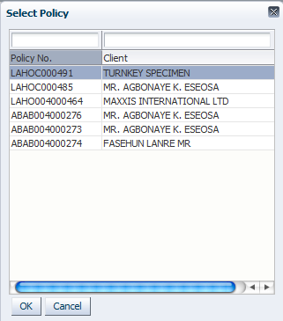

* Select a policy and click  to populate the field.
* Click  to proceed directly to the policy underwriting landing screen.

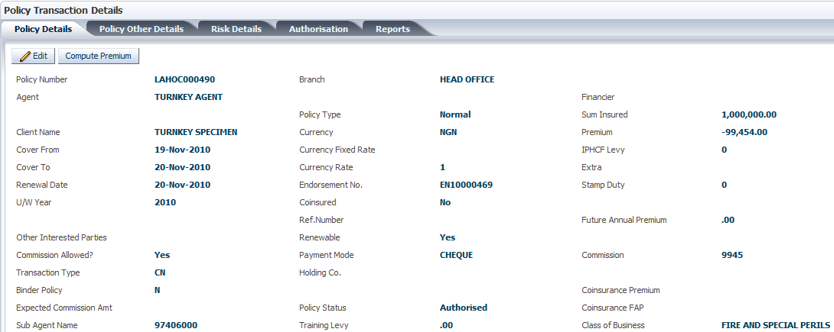

* Click  to populate the ‘Search Result’ pane with the policy that was selected.

: Click  to clear search fields and  to clear search fields and results.

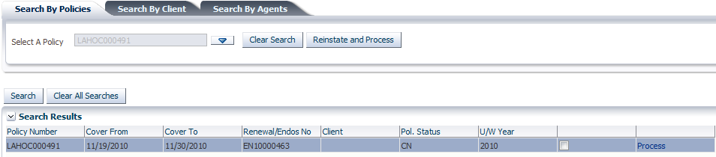

* Click the ‘Process’ link to proceed to the policy underwriting landing screen as above



* Click  to compute the premium.
* Click the ‘Authorisation’ tab

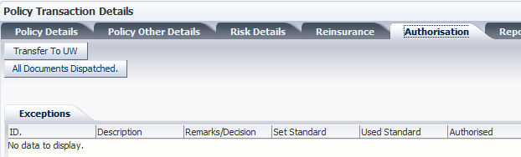

* Click  to prepare the reinstated policy for underwriting. This brings up the policy underwriting landing screen again
* Compute premium, authorize the policy, dispatch policy documents and print reports as usual.

# POLICY LOADING

This process is for loading already existing policies into the system.

* Click **Underwriting**>>**Load Policies.** This brings up the ‘Load Policies’ screen

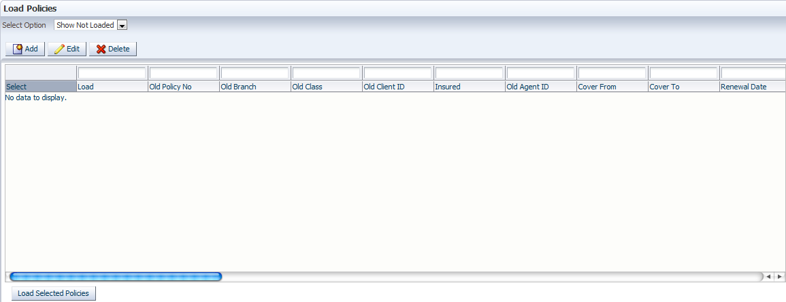

* The ‘Select Option’ field specifies the items to be listed on the screen.
* Click  and select ‘Show Not Loaded’ to show policies whose details have been entered but have not been loaded in the system.
* Select ‘Show Loaded’ to show policies whose details have been entered and loaded.
* Select ‘Show All’ to show policies in both groups.
* Click  to bring up the ‘Add/Edit Policy Details’ dialog box

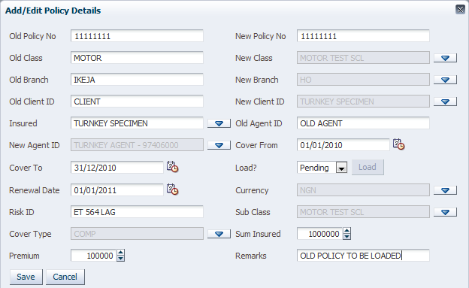

* The ‘Old Policy No’ is the current policy number.
* The ‘New Policy No’ is the new policy number to be assigned to the policy after it is loaded into the system.
* The ‘Old Class’ is the class of business the insured is currently covered in.
* The ‘New Class’ is the class of business in the system under which the insured is to be covered.
* The ‘Old Branch’ is the branch in which the policy was originally underwritten.
* The ‘New Branch’ is the branch in the system to which the business is to be attributed for reporting purposes.
* The ‘Old Client ID’ is the name of the client as captured in the policy.
* The ‘New Client ID’ is the name of the client as defined in CRM.
* The ‘Insured’ is the party who is covered in the policy. It could be the same as the client.
* The ‘Old Agent ID’ is the nameof the agent as it is defined in the policy.
* The ‘New Agent ID’ is the name/ID of the agent as defined in CRM.
* The ‘Cover From’ and ‘Cover To’ dates define the cover period.
* The ‘Renewal Date’ is the day the policy is expected to be renewed after it expires.
* The ‘Currency’ is the currency in which the policy is to be underwritten in the system.
* The ‘Risk ID’ is a short description for identifying the risk to be covered.
* The ‘Sub Class’ is the subset class under the class of business for which the policy is drawn up.
* The ‘Sum Insured’ is the value of the risk on which premium will be computed.
* The ‘Premium’ is the premium charged the client on the policy.
* Click  to save the record.

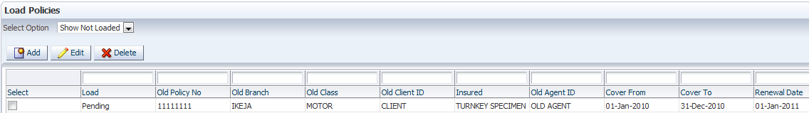

: The ‘Load’ status shows it is pending.

* Check the checkbox against each policy to be loaded and click. The record is removed from the screen.
* For the ‘Select Option’ field, select ‘Show Loaded’ to view the policy/policies that has/have just been loaded.

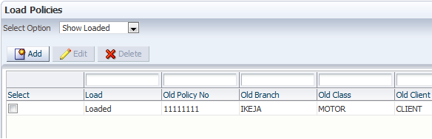

: The ‘Load’ status shows the policy has been loaded.

# POLICY ADMINISTRATION

Policy administration is done to continue the processing of loaded policies.

* Click **Underwriting**>>**Policy Administration** on the main menu panel. This brings up the ‘Policy Administration’ screen.

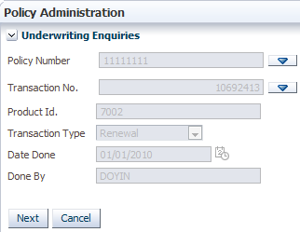

* The ‘Policy Number’ field specifies the policy number assigned to the loaded policy.
* Click  to bring up the ‘Policies’ dialog box with a list of loaded policies.

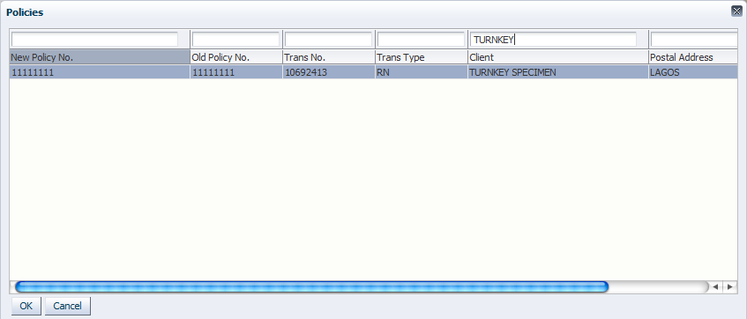

* Select a policy and click  to populate the field.

: All other fields are automatically populated.

* The ‘Transaction No.’ is the number of the transaction done on the policy. In the above screenshot, the transaction type is a renewal and the transaction number is shown in the column before it.
* The ‘Product Id.’ Field specifies the code assigned to the subclass in the policy.
* The ‘Transaction Type’ indicates that this policy transaction is a renewal.
* The ‘Date Done’ field shows the ‘cover from’ date when the policy cover starts.
* The ‘Done By’ field shows the user who loaded the policy in the system.
* Click  to proceed to the policy underwriting landing screen.

# REINSURANCE

1. ***Surplus Treaty Reinsurance***

There are two areas where a user can perform reinsurance on an authorized policy. The first is immediately after authorizing the policy. After authorizing, a new tab (Reinsurance Tab) is generated on the policy landing screen.

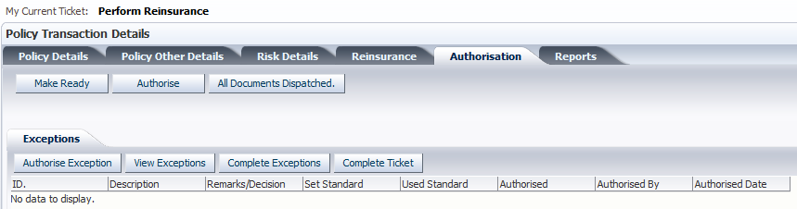

After authorizing the policy and dispatching policy documents, the ‘My Current Ticket’ status changes to ‘Perform Reinsurance’ and the reinsurance tab appears.

* Select the ‘Reinsurance Tab’

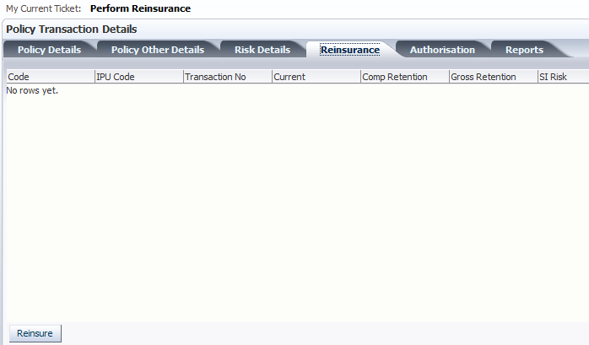

* Click  to bring up the ‘Reinsurance Apportionment’ screen

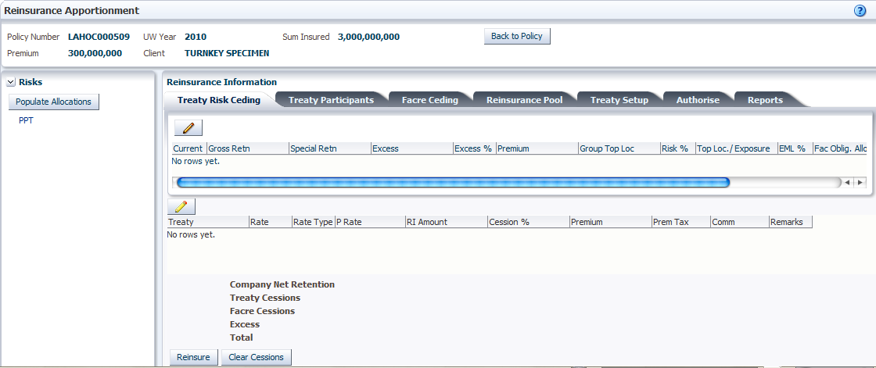

* Click on the risk in the policy to reinsure. The risks are listed below the ‘Populate Allocations’ button on the ‘Risks’ pane to the left.
* Click  to generate the policy and treaty arrangement amounts.

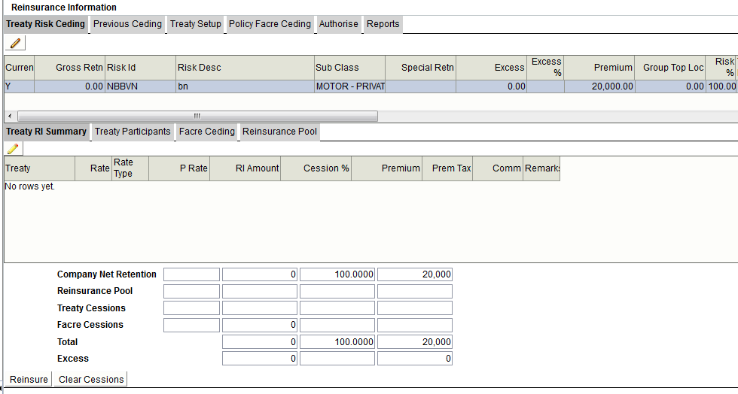

* Select the cession details record to generate the treaty details from setup.

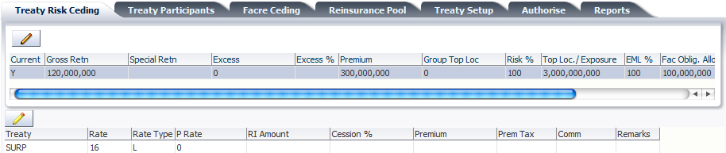

* Click  to edit the cession details in the upper part of the ‘Treaty Risk Ceding’ tab.

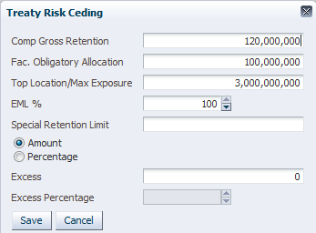

* The ‘Comp Gross Retention’ is the company’s retention.
* The ‘Fac. Obligatory Allocation’ is the amount ceded to facultative obligatory.
* The ‘Top Location/Max Exposure’ is the maximum exposure amount of the risk to be reinsured.

: The top location refers to the level at which the risk value is captured – risk or section.

* The ‘EML%’ is the percentage of the risk exposed.
* The ‘Special Retention Limit’ is an exception to the amount specified as the company’s retention. The treaty amount is computed based on the special retention limit and the treaty allocation for the company is based on the Company Gross Retention.
* Select the ‘Amount’ or ‘Percentage’ radio button to indicate whether the special retention limit stated is an amount or a percentage of the company’s retention.
* ‘Excess’ and ‘Excess Percentage’ are automatically computed.

: The excess is the sum insured less the sum of the retention and the treaty amount. The excess percentage is the percentage of the sum insured that is the excess.

* Click  to save the record.
* Click  to compute the ‘Treaty Cessions’, ‘Facre Cessions’ and ‘Excess’.

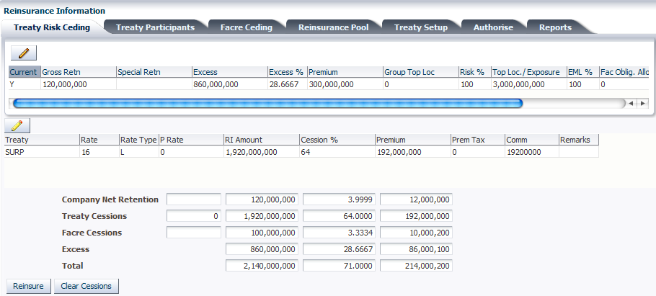

:

* The three columns show the ‘allocation amounts’, ‘allocation percentages of the sum insured’ and the ‘premium on each allocation amount’ respectively. The allocation percentage is the percentage of the sum insured that makes up the allocation amount while the allocation premium is the allocation percentage of the premium on the risk.
* The ‘Company Net Retention’ is **120,000,000.** This is **4%** of the sum insured. **4%** of the premium is in turn, **12,000,000.**
* The ‘Treaty Cession’ is computed based on the ‘Company Net Retention’ and the company’s ‘Cession Rate’. In this case, the retention is **120,000,000** and the rate is **16 lines**. This makes the treaty cession **120,000,000** x **16** = **1,920,000,000**. This amount is **64%** of the sum insured (**300,000,000,000**) as shown in the next column. The last column shows the treaty premium (**192,000,000**) which correspondingly, is **64%** of the premium (**300,000,000**) on the risk.
* The ‘Facre Cessions’ is the total amount ceded to the Facultative Obligatory participant set here at **100,000,000**. This amount is **3.3334%** of the sum insured. **3.3334%** of the premium is in turn, **10,000,200.**
* The ‘Excess’ is the sum insured (Maximum Exposure) less the sum of the Company Retention, the Treaty Cession and the Facultative Obligatory Cession (Facre Cessions). That is, **3,000,000,000** – (**120,000,000** + **1,920,000,000** + **100,000,000**) = **860,000,000**. This amount is **28.6700%** of the sum insured. **28.6700%** of the premium is **86,000,100.** The excess is to be ceded to facultative parties as facultative outward business.
* The Total is the sum of the Company Retention, the Treaty Cession and the Facultative Obligatory Cession (Facre Cessions). That is, **120,000,000** + **1,920,000,000** + **100,000,000 = 2,140,000,000.**
* Select the cession details record and then select the surplus treaty setup details below it.

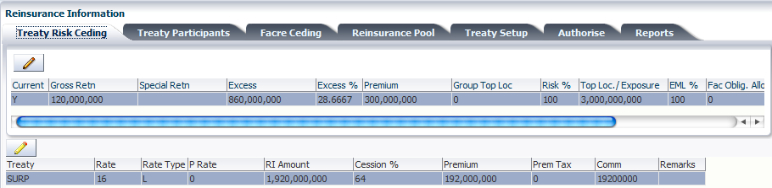

* Click the ‘Treaty Participants’ tab to view the treaty participants.

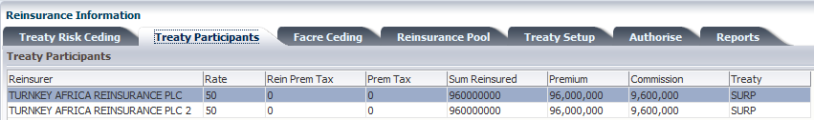

:

* Each participant has a cession rate specified at treaty setup. In this case, each participant has a rate of **50%**, that is, **50%** of the treaty amount which is **1,920,000,000** as shown above. This allocates **960,000,000 (50%** of **1,920,000,000)** to each participant since they have an equal share of **50%**.
* The ‘Premium’ for each participant is the percentage of the treaty premium based on the allocation percentage for the participant. Treaty premium = **192,000,000. 50%** of **192,000,000 = 96,000,000.**
* The ‘Commission’ is computed as a percentage of the premium based on the commission rate set up for the treaty.

### Facultative Ceding

In facultative outward reinsurance, the company cedes part of a risk that is above the treaty capacity to one or more reinsurers/Insurers on an individual risk agreement. The excess computed on the previous screen is ceded to facultative parties either using parts of the total percentage of the sum insured that makes up the excess or using specific sums out of the excess amount.

* Click the ‘Facre Ceding’ tab.

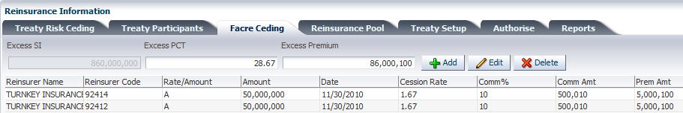

:

* The facultative obligatory participants are displayed on the screen by default provided the facultative obligatory allocation amount has been specified at treaty setup or on the ‘Treaty Risk Ceding’ tab.
* The participants are defined at setup and the allocation is shared according to the cession rates specified.
* The ‘Rate/Amount’ column shows the factor by which the amount for the participant was allocated. ‘A’ denotes amount and ‘R’ denotes rate.

1. ***Defining Profile Bands***

Profile bands are defined for the purpose of risk profiling. Risk profiling involves the banding of risks according to their sum insured and premium for the risk in each band. RI prepares these reports monthly, quarterly, half annually and annually.

* Click **Reinsurance**>>**Profile Bands** on the main menu panel. This brings up the ‘Risk Profile Bands’ screen.

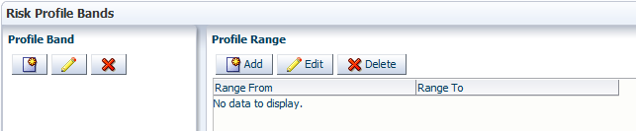

* To define a new profile band, click. This brings up the ‘Add Profile Band’

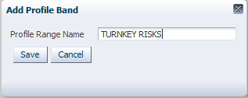

* Specify the name of the band in the ‘Profile Range Name’ text box and click  to save the profile band.

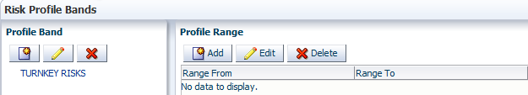

* To specify profile ranges for a band, select the profile band to specify ranges for and click  on the ‘Profile Range’ pane to the right. This brings up the ‘Add Range’ dialog box.

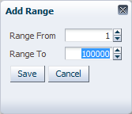

* Specify the ‘Range From’ and ‘Range To’ sum insured amounts and click  to save the range for the selected profile band.

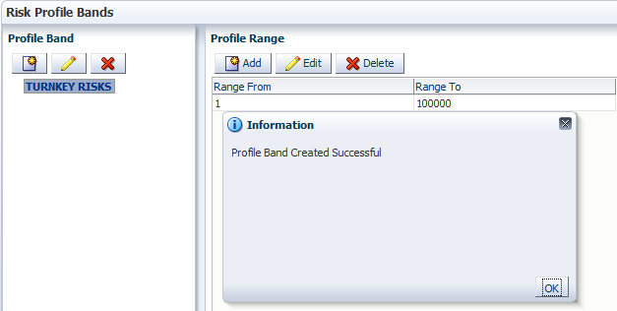

* Repeat the steps for defining the range to continue the sequence in multiple ranges for the same band.

1. ***Risk Profiling***

After defining profile bands, risk profiling is done based on the bands that have been defined.